CURRICULUM VITAE
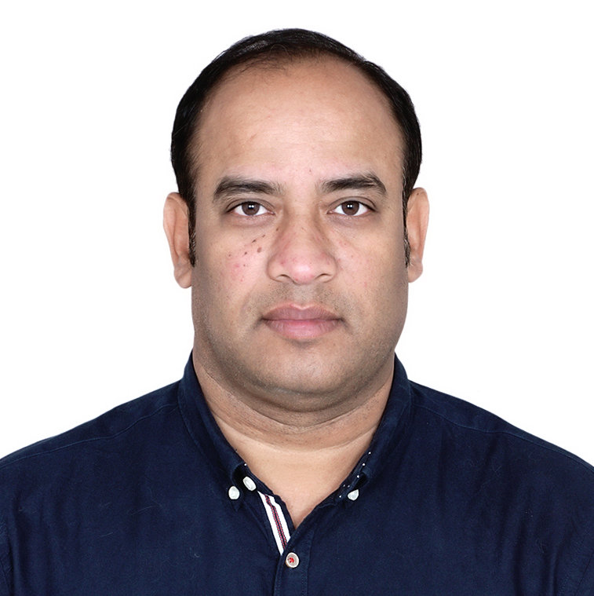

SUBIR DEY SARKAR
CONTACT : + 971 - 521352185
sarkar203@rediffmail.com

CAREER OBJECTIVE:
Seeking a challenging position that adds value, where my experience and skills can be applied and further developed.

PERSONAL DETAILS:

Date of birth : 08 June 1974

Height : 5’7”

Nationality : Indian

Marital status : Single

Driving License : Qatar & Indian Full Clean License

Permanent address : B20, 2nd floor, Vishwakarma colony, New Delhi-110044, India

Languages spoken : English, Hindi, Bengali

WORK EXPERIENCE:

ORGANIZATION: AL NABIT INTERNATIONAL SERVICES - DOHA, QATAR
TENURE: SEPTEMBER 2017- DECEMBER 2018
POSITION: OPERATION SUPERVISOR

      - Recruitment of staff.
      - Training & development of staffs.
      - Day to day man power operation supply.
      - Preparing schedule & work assignments.
      - Following up new business opportunities and setting up meetings.
- Preparing daily reports.
- Providing client feedback to partners.

ORGANIZATION: MORNING STAR TRADING & HOSPITALITY - DOHA, QATAR
TENURE: JULY 2014-JUNE 2016
POSITION: SENIOR SUPERVISOR
- Helping the team understand performance targets and goals.
- Training or ensuring that workers are properly trained for their specific roles.
- Scheduling work hours and shifts.
- Coordinating job rotation and cross-training.
- Providing real-time feedback on worker performance.
- Assisting in resolving emergencies.
- Providing reports and activity updates to management.
- Assisting in hiring and firing activities, although often the supervisor requires managerial approval of all new hires or terminations.

ORGANIZATION: AJMAN TRADING COMPANY DOHA, QATAR
TENURE: AUGUST 2012 – MARCH 2014
POSITION: SALES EXECUTIVE

- Organizing sales visits.
- Demonstrating and presenting products.
- Establishing new business.
- Maintaining accurate records.
- Attending trade exhibitions,
- Reviewing sales performance.
- Aiming to achieve monthly or annual targets.

ORGANIZATION: DOHA GOLF CLUB, DOHA, QATAR
TENSURE MAY 2004 – MARCH 2012
POSITIN: F&B HUT SERVICE CAPTAIN

- Receiving function order and follow up
- Preparing weekly Rota for staff
- Prepare duty reports
- Follow up of F & b to be served at the appropriate time
- Checking staff for grooming and standard service
- Supervise weekly and monthly stock in all the F & B outlets
- Responding to guests need upon request
- Total commitment to quality service to members and guests from all outlets
- Assist in general day to day running of all the F & B outlets
- Coordinating all the F & B outlet staff and maintain excellent relation
- Distribution of function & event sheet to all concerned areas

ORGANIZATION: STANLEY LEATHER – NEW DELHI, INDIA
TENURE: JAN 2001-FEB 2004
POSITIO: AREA SALES EXECUTIVE

- Coordinating the sales of leather upholstery for all premium cars and instrumental in selling the maximum packages in New Delhi and Punjab.
- Responsible for corporate business from Oswal Group, Hero Honda, Marubeni Corporation etc.
- Monitoring dealership proposals and Dealership sales in New Delhi, Punjab.
- Organize product awareness campaigns and arrange seminars for new product launches.
- Target sales in unrepresented areas and arrange Dealers meeting for brand promotion.

ORGANIZATION: LACOSTE – NEW DELHI, INDIA
TENSURE: JAN 1999 – JAN 2001
POSITION: SALES EXECUTIVE

- Empathies with and foresee the needs of target customers and harvest the opportunity
- Educate and upgrade the consumer in order to raise expectations and widen markets
- Build values in the product offer that makes more than the tangible expression of features
- Follow systems and improve the market share of products and services

EDUCATION:

- Secondary from National Open School of Board at New Delhi, India.

PERSONAL ATTRIBUTES

- Well organized, self-motivated, always completes the task
- Adaptable to challenges under contrasting working environments
- Strong analytical skills, creative in problems solving
- Team player
- Effective communication
- Goal orientated and decisive
- Detail oriented
- Enjoy learning & developing different skills.
- Time management

