**Shajith**

**Basheer**

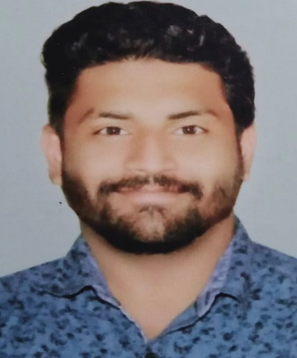

**Contact**

**Address:**

Ibn Seena St, Doha

**Phone:**

+974 - 31686278

**Email:**

Sha3121988@gmail.com

**LinkedIn:** [**linkedin.com/in/shajith-basheer-60126b4b**](https://www.linkedin.com/in/shajith-basheer-60126b4b?lipi=urn%3Ali%3Apage%3Ad_flagship3_profile_view_base_contact_details%3B6bwJcMfvQgO1tOt6XkXDtg%3D%3D)

**Languages**

English

Hindi

Arabic

Malayalam

Tamil

**Hobbies**

* Cricket
* Football
* Reading
* Driving

**Summary**



Driven Business Development Executive with career history in multi-state distributed businesses and proven skill in hiring, developing, and retaining high-performance teams. Motivating leader with strengths in building strategic relationships to support key business initiatives. Highly skilled in change management, management transition and

merger integration. Offering excellent interpersonal and communication skills and experience managing matrixed organizations.

**Skill Highlights**



|  |  |  |  |  |
| --- | --- | --- | --- | --- |
| * • | * Strong decision maker |  | * Service-focused |  |
| * • | * Teamwork |  | * Operations |  |
| * • | * Customer satisfaction |  | * Business development |  |
| * • | * Effective negotiator |  | * and planning |  |
| * • | * Marketing | * Marketing strategy |  |
| * • | * Handling Conflict |  | * Leadership |  |
|  | * Sales |  | * Lead Generation |  |

**Experience**



**Business Development Executive,** *[****Dec 2021* *–* *Present]***

Sulfur Chemical W.L.L

***Marketing Development Executive,[ Jun 2020 - Nov 2021]***

*Vajra Plastics ,Kerala, India*

***Marketing Executive,[ Jan 2017 - Mar 2020]*** *Sulfur Chemical Material Trading L.L.C ,Ajman, UAE*

***Quality Manager, [ May 2014 - Nov 2016]***

*Gulf Water Plant ,Doha, Qatar*

***Chemist, [Mar 2012 - Sep 2013]***

*Al Jazeera Drinking Water Company W.L.L*

***Chemist, [Jun 2011 - Feb 2012]***

*AVT Natural Products Ltd, Kerala, India*

***Scientific Assistant,[ Jun 2009 - May 2011]*** *Ammonium Perchlorate Experiment Plant ,Kerala, India*

**Education**



**Bsc. Chemistry(**M.G. University, Kerala ,India)

**Al-Ameen College, Edathala, Aluva, Kerala**

*Jun 2006 - Mar 2009*