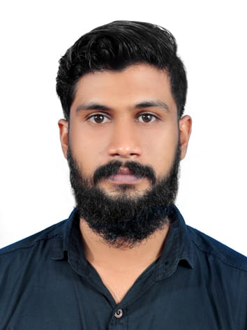

**NAME:SAVAD MOB:+0543271309 EMAIL:Savadkannanalloor@gmail.com**

# OBJECTIVES

**To work in an environment that will help me in contributing towards the goals of the organization and continuously upgrade my knowledge.**

**ACADEMIC DETAILS**

|  |  |  |  |  |
| --- | --- | --- | --- | --- |
| **Qualification** | **Year Passed** | **Board/Univ.** |  | **INSTITUTION** |
| **ITI** | **2013** | **NCVT (GOVT OF INDIA)** |  | **V INSTITUTE**  **(KOLLAM)** |
| **X** | **2010** | **KERALA STATE BOARD** |  | **MKLMHSS (KANNANALLOOR)** |

**EXPERIENCE DETAILS**

**TECHNICAL ASSISTANT - FZE KROMBERG & SCHUBERT - DUBAI: 2019 - Ongoing**

**SUPERVISION - RR CONSTRUCTION - KOLLAM: 2016 - 2018**

**INDOOR SALES - HERO - KOLLAM: 2014 – 2016**

**SKILLS**

**➢ Oversee the sales process to attract new clients.**

**➢Work with senior team members to identify and manage risk.**

**➢Maintain fruitful relationships with clients and address their needs effectively.**

**➢Identify new leads and market opportunities.**

**➢ Strong analytical problem solving, organizational ability.**

**➢ Ability to deal with people diplomatically**

* **STRENGTHS**

**➢ Communicates effectively and a good listener**

**➢ Hardworking**

**➢ Have good leadership power**

**➢ Focus on carrier goals and objective**

# HOBBIES

**➢ Listening melodious music**

**➢ Playing Football**

**➢ Watching Movies**

**➢ Travelling**

**COMPUTER PROFICIENCY**

* **Microsoft Office.**
* **Internet and email.**

**LANGUAGE**

**Languages: Malayalam, English, Hindi, Tamil**

**EXTRA CURRICULAR ACTIVITIES**

* **Actively participated in different activities like organising different events in school and College level.**
* **Won prizes at school level Sports Activities.**

**PERSONAL DETAILS**

**Father’s Name: EBRAHIM KUTTY A**

**D.O.B: 21 MAR 1993**

**Postal Address: SCHARUVILA PUTHEN VEEDU**

**EDAPPANTHOD**

**NEDUMPANA (PO)**

**KOLLAM – 691576**

**KERALA**

**Gender: MALE**

**Nationality: INDIAN**

**Passport Details**

* **Passport Number: INDIAN PASSPORT M 1753583**
* **VISA STATUS: VALID TILL 07/09/2024**

**Indian Heavy Driving License**

**License No: 2/1069S/2013**

**Declaration**

**I hereby declare that the above furnished details are fully true to the best of my knowledge and belief.**

**Date: Yours Sincerely,**

**Place: DUBAI SAVAD**