*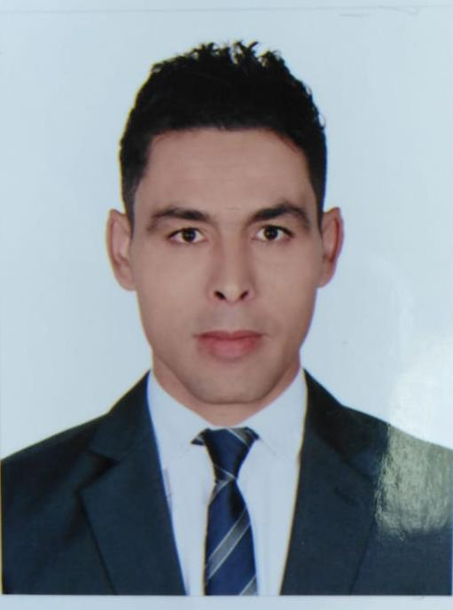Mohamed AHLAMINE*

*telephone-gsm-mobile-phone-logo.jpg*  [**ahlaminem728@gmail.com**](mailto:ahlaminem728@gmail.com)

**google-location-icon-location-icon.png 971 52 495 5698**

**Tourist Club , Abu Dhabi United Arab Emirates**

***Objective***

*Seeking a suitable position for substantial responsibility where my past and varied experience would fully utilized in a career opportunity and where making a significant contribution to the success of my employer will gain me career advancement opportunities.*

***Experience***

***BAIT ALMOSAKHAN RESTAURANT***

***Supervisor*Novembre 2015 to Novembre 2018**

  Working within a reception environment providing a telephone answering, admin and reception service as well as organizing the post, welcoming visitors and providing hospitality towards guests and clients .

***Duties:***

* Answering all incoming calls / emails and re-routing them to relevant parties.
* Meeting and greeting visitors ensuring they are signed in and inducted.
* Opening, distributing, collecting and taking the post.
* General administration duties, photocopying, filing etc.
* ***Brand (Puma store)***

Department: commercial

Category : salesman

Location: morocco mall ( Casablanca morocco )

(since Aug 2013 till Oct 2015).

* Essential duties and responsibilities :

Turnover: Sales Targets: ensures monthly target

Promotes maximum sales of merchandize by:

* Establishing customer needs.
* Explaining Features and Benefits.
* Overcoming Objections.
* Selling Add-on Merchandize.
* Providing high quality customer service.
* Customer Service:

Consistently maintains the highest Standards of customer service by:

* Respecting the well being of the customer, dealing with her/ him as a guest and as potential customer, regardless of the nationality, color age and gender.
* Greeting the customers with a smile, advising them which product to buy.
* Advising customers on the selection, price, use service of product range available in the showroom, with the aim of encouraging them to buy and become a key customer.
* Precisely and correct answering a variety of questions concerning any available product; demonstrates the use of merchandize upon request.
* Professionally, diplomatically and politely dealing with customer complaints in accordance to the company procedures. Any complaints that remain unresolved are to be referred to the Brand manager.

***Education and Certificates:***

* 2011-2013 : diploma of administrative and management morocco .
* 2010 : high school (3 years).

***Personal detail :***

**Nationality:** Moroccan

**Date of Birth:** Feb 04, 1985

**Marital Status:** Single

**Visa Status:** Residence Visa (Employment-Transferable**(3 years) (3 years)**)

***Language skills:***

* Arabic: mother language fluently speaking reading and writing
* French: fluently speaking reading and writing.
* English: fluently speaking reading and writing.