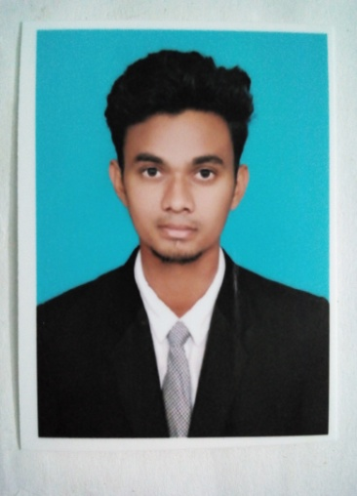

**MOHAMED FALUL**

E-mail: mohamedfalul13@gmail.com

Mobile:056 2676595

Address:All muteen

Dubai



**Career Objective**

To secure a challenging and regarding position where I can effectively contribute my skills and achieve high carrier growth through a continuous learning process and keep myself dynamic, visionary and competitive with the changing scenario of the world.

**Academic Qualifications**

* B.E in Electronics & Instrumentation Engineering from Saveetha Engineering College in Chennai(June 2014 to may 2017)
* HSC from Gandhi Matriculation Higher Secondary School, Madukkur, Thanjavur,Tamil Nadu,India
* SSLC from Gandhi Matriculation Higher Secondary School, Madukkur,Thanjavur,Tamil Nadu,India

**Work experience**

**BlackBox GPS technologies Pvt Ltd Bangalore(karnataka)**

Position: **Field service engineer**(July 2018-Nov 2019)

* Follow up on manufacturing and field reports and resolved outstanding problems
* Provided on-site field technical support,including but not limited to end user problem solving
* Developed and improved preventive maintenance procedures
* Troubleshooting,wiring,calibrating and given on-site demo to the customers

**RANE NSKSteering Systems Pvt LTD Chennai(Tamilnadu)**

Position: **Quality controller trainee**(Nov 2017-june 2018)

* A competent professional over 6 month of experience in Production, Quality control ,Team management
* Executed production operations in coordination with the functions managed the workmen for achieving the periodic production targets
* Reduced rejection level & rework through continuous up gradation of quality circles to observe better compliance in line with changing customer requirements
* Adept at handling day to day activities in coordination with internal/external departments for ensuring smooth production operations

**Project Taken**

* A Modeling and design of Active suspension system using MPC and PID controller

**Description**

* The objectives of this study are to obtain a mathematical model for the passive and active suspensions systems for quarter car model. Current automobile suspension systems using passive components Passive suspensions only offer compromise between these two conflicting criteria. Active suspension poses the ability to reduce the traditional design as a compromise between handling and comfort by directly controlling the suspensions force actuator, Comparison between passive and active suspensions system are performed by using different types of road profiles.

**Presentation**

* Presented & entitled” **Modeling and design of active suspension system using PID and MPC Controller”** in the FIRST INTERNATIONAL CONFERENCE ON INSTRUMENTATION, ELECTRICAL AND ELECTRONICS ENGINEERING (ICIEEE’17) held at Saveetha Engineering College, Chennai.

**Professional Certifications**

* Industrial Automation Training using PLC
* Industrial Automation Training using SCADA
* Completed “Diploma in Computer Application(DCA)”over a 2 month period

**Workshops**

* Attended a five Days Workshop On Embedded System in UNIQ TECHNOLOGIES
* Attended the Training in a Five Days Workshop On YOKOGAWA TECHNICAL SCHOOL of education in DCS & PLC OVERVIEW

**Technical skills**

* Improved knowledge in C, C++, HTML, MS office 2007, 2010, and 2013.
* **PLC** (Programmable Logic Controllers) & **DCS** (Distributed Control System) - Programming languages such as **LD**(Ladder Diagram) & **FBD** (Functional Block **D**iagram)
* **SCADA** (Supervisory Control & Data Acquisition) – Screen designing, PC & PLC interface
* Handson Practical exposure in brands as **Siemens**,
* DCS & PLC Overview using centum vp software
* Knowledge in **PID**(Proportional Integral Derivative)
* **HMI** (Human Machine Interface) - PLC interface, DCS interface
* Improved knowledge in MATLAB software

**Personal Competency**

* Retain respectable communication and interpersonal skills.
* Ability to negotiate and deliver ideas.
* Ability to handle and organize multiple tasks simultaneously.
* Good planner and performer, ensuring predictable quality of technical tasks

**Personal profile**

**FULL NAME** : **MOHAMED FALUL.A**

NATIONALITY : INDIAN

DATE OF BIRTH : 13th -JULY-1996

LANGUAGES KNOWN : ENGLISH, TAMIL ,Malayalam

AVAILABLE : IMMEDIATELY

PASSPORT NO. : J4327489

VISA STATUS. : visit visa

**Declaration**

I here by declare that the above particulars furnished by me are true to the best of my knowledge and belief.

Yours Sincerely,

**MOHAMED FALUL**