Maya Magar

***CURRICULUM VITAE***

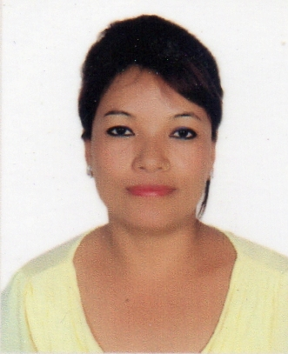

Maya Magar

Al Ruwais, ADNOC housing

Abu Dhabi, ***Phone: +971554410589***

UAE **Email Id**:mayakusum43@gmail.com

OBJECTIVE:

To work with diligence, excellence and intelligence, and to enhance my skills as being a part of the reputed company with the growth and success with the contribution of my experience

QUALIFICATIONS:

* 0' level education is done at native place by native language

PROFESSIONAL EXPERIENCE:

* ***Royal catering services LLC, Abu Dhabi***

***Designation:*** Floor attendant

From:May 2018 – till date

* ***Le Cafe, Chennai, India***

***Designation:*** Floor attendant

From: September 2014 - October 2016

* ***Royal Park Restaurant, Male. Maldives***

**Designation:** Floor attendant

From: September 2013 to may 2014

