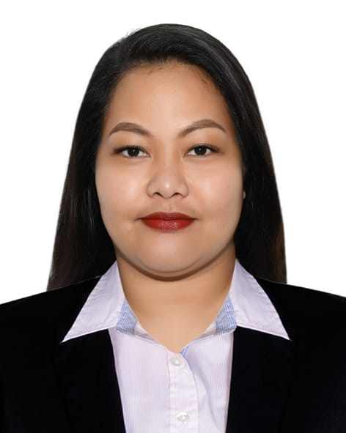**MARIANNE V. CANESO**

Alrigga Dubai, UAE.

Email:mariannecaneso@gmail.com

Mobile No. **0523543385**

**Education Background**

Elementary: Don Amadeo Perez Senior Memorial Central School.

High School: Urdaneta City National High School.

**Skills**

* Massage Therapist
* Facialist
* Manicure
* Pedicure
* Eyelash Extension
* Nail Extension Acrylic
* Eyelash Perm
* Nail Extension Poly Gel
* Nail Extension Baby Boomer
* Nail Artist

**Employment Record**

**The Dubai Salon**

Rixos Premium

Dubai, JBR

April 15, 2021 – October 31, 2021

* Nail Technician

**CREATION BEAUTY LOUNGE**

**ALJURF 1 AJMAN DUBAI UAE**

March 03, 2019 – October 11, 2020

**Receptionist / Nailtechnician**

* Welcome and greet the customer coming.
* Assist and show the promotional packages.
* Attentive to the need of the clients in terms of services.
* Auditing and inventory of stocks.
* Incharge of billing and Purchasing.
* Bookings and Reservations.
* Encoding file documents.
* Selling promotional packages and convince the client.
* MS office and Excel.

All About You/Skin Care & Spa:Urdaneta City Pangasinan Philippines

June 03, 2013/April 15, 2016

Shearmhaz Salon and Spa/Urdaneta City Pangasinan Philippines

July 15, 2017/December 01, 2018

Data:

Nationality: Filipino

Religion: Christian

Place of Birth: Nancalobasaan Urdaneta City Pangasinan

Birth Of Month:February 23,1992

Status:Single

Height: 5,5

Weight: 75

I hereby certify that all the information is true and correct to the best of my knowledge.

Marianne V. Caneso