|  |  |  |
| --- | --- | --- |
| **JOHN OLUPOT** | | |
|  | **Nationality**: **Ugandan**  **Tel No: +971 581670409**  **Email: olupotjohnasianut@gmail.com**  **Visa Status: Visit Visa**  **Gender: Male**  **Address: Al Satwa** |  |

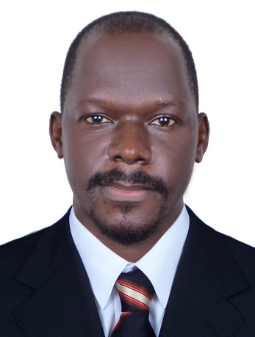

|  |  |  |  |
| --- | --- | --- | --- |
| **profile**  Results-oriented sales professional with 10 years of experience in both consumer and non-consumer products and a proven track record of exceeding quarterly sales. Highly skilled at creating new relationships and maintaining strong customer relations to create a wide client base and generate revenue. In-depth knowledge of effective sales strategies and exceptional presentation skills. Analytical thinker with the ability to perform well under pressure. Goal and team-oriented with strong leadership and communication skills. |  |  |  |
| **WORKING EXPERIENCE.**  **Retail Sales Manager, Big Savers Supermarkets. (2019-2021).**  **Responsibilities.**   * Directing and supervising staff engaged in sales, inventory-taking, reconciling cash receipts or in performing services for customers. * Guiding staff on how to handle difficult and complicated sales. * Examining merchandise to ensure that it is correctly priced, well displayed and that it functions as advertised. * Recommend, select and help locate merchandise based on customer needs and desires. * Monitor sales activities to ensure that customers receive satisfactory services and quality goods. * Hire, train, post and evaluate personnel performance in Sales and Marketing establishments. * Enforce safety, Health and security rules.   **Retail Sales person, Big Savers Supermarkets. (2015-2018).**  **Responsibilities;**   * Greet and direct customers * Provide accurate information (e.g. product features, pricing and after-sales services) * Answer customers’ questions about specific products/services * Conduct price and feature comparisons to facilitate purchasing * Ensure racks are fully stocked as per the recommendation * Coordinate with the Retail Sales Representatives team to provide excellent customer service (especially during peak times) * Inform customers about discounts and special offers * Provide customer feedback to the Store Manager * Stay up-to-date with new products/services   **Sales executive Electronic security products, Guards, K9 Tight Security Limited**  **2010-2017**  Responsibilities:   * Meeting with clients virtually or during sales visits * Demonstrating and presenting products * Establishing new business * Maintaining accurate records * Attending trade exhibitions, conferences and meetings * Reviewing sales performance * Negotiating contracts and packages * Working towards monthly or annual targets * Communicating job expectations and Monitoring business progress * Reporting to management about any business opportunities available for a tap in. * Evaluating business performance and developing marketing strategies.   **TRAINING AND EDUCATION BACKGROUND.**  **D**iploma in **R**ecords **M**anagement - **YMCA** Institute  **U**ganda **A**dvanced **C**ertificate of **E**ducation – Kololo Secondary School.  Marketing and sales trainings at Big savers, Tight security and Airtel Telecom respectively  Valid Ugandan Driving license  Emergency First Aid Training.  Fire and Safety training. |  |  |  |