**JOFFY JAMES** 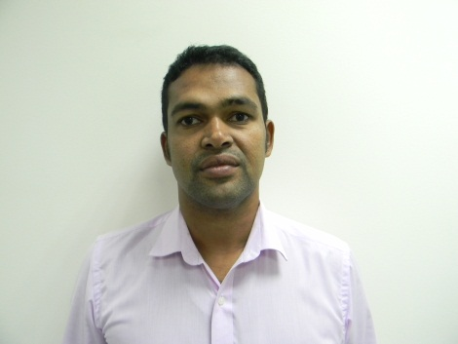

**UAE DRIVING LICENSE: 3659656**

**OMAN DRIVING LICENSE: 66517658**

**Email:** [**joffyjames26@gmail.com**](mailto:joffyjames26@gmail.com)

**GSM # + 00971 523492418 / 0091 4872427186**

**OBJECTIVE**

Seeking for challenging career in your esteemed organization. Given an opportunity, I promise to perform my assigned duties with sincerity, dedication and to enhance my present career.

**ATTRIBUTES**

* ENTHUSIASTIC
* WILLING TO LEARN
* RELIABLE
* RESPONSIBLE
* HARDWORKING WITH POSITIVE ATTITUDE & RESULT ORIENTED

**PROFESSIONAL SKILLS**

* MARKETING & SALES
* NEGOTIATION SKILLS
* INVENTORY MANAGEMENT (WHOLESALE & RETAIL)
* DEALER MANGEMENT

**EDUCATIONAL QUALIFICATION**

1. **ACADEMIC SKILLS**

|  |  |  |  |  |
| --- | --- | --- | --- | --- |
| S.NO | COURSES | BOARD /UNIVERSITY | SCHOOL/COLLEGE | YEAR OF PASSING |
| 1. | P.D.C | CALICUT UNIVERSITY | CHINMAYA MISSION COLLEGE | 1998 |
| 2. | S.S.L.C | BOARD OF SECONDARY SCHOOL | SEVENTH DAY ADVENTIST HIGH SCHOOL | 1996 |

1. **TECHNICAL SKILLS**

Certified Course In Electronics At JAMES ELECTRONICS, THRISSUR ,KERALA,INDIA.

**WORK EXPERIENCE**

* + - As a salesman at ALMAYA TRADING COMPANY , DUBAI from February 2017-2019.
    - Salesman at 1004 Mart General Trading LLC, DUBAI from 2nd January 2016 - 2017.
    - Shop Incharge Cum Administration Assistant In BAHJAT AL KHALEEJ LLC- MUSCAT, SULTANATE OF OMAN from 2002 July-2016 December.
    - Sales Representative at GEO ELECTRONICS- SANTA CRUZ-MUMBAI ,INDIA from 2000 February-march 2002.

**PERSONAL PROFILE**

FATHER’S NAME: K.V.JAMES.

DATE OF BIRTH : 11TH DEC, 1979

NATIONALITY : INDIAN

RELIGION : CHRISTIAN

MARITAL STATUS : MARRIED

PASSPORT NO : A8110471

LANGUAGES KNOWN: ENGLISH, ARABIC, HINDI & MALAYALAM

PERMANENT ADDRESS : V/288, KANGAPPADAN HOUSE,CHELAKOTTUKARA ,TRICHUR, KERALA,INDIA.

DECLARATION

I HEREBY DECLARE THAT ALL THE ABOVE MENTIONED INFORMATIONS ARE TRUE TO BEST OF MY KNOWLEDGE.

SIGNATURE: DATE: 2-2-2019