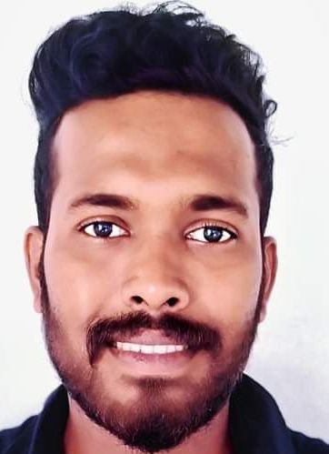

**Isuru Adhikari**

Senior executive-apparel manufacturing.

To work in progressive environment which offer enough challengers and opportunities for me to expand upon my knowledge and grow as a competent professional, while adding value to the organization.

**Senior exective**

**PRODUCTION COORDINATOR**

**FASHION BUG (PVT) LTD**

**2021 APRIL TO PRESENT**

Coordinate with all stake holders of clothing manufacturing process to full fill the fashion requirement of Fashion Bug branches.

As a head of production department, overlook the operations of in plant production module, outsource manufactures, quality team and costing center.

Directly involve with Fashion Designers to develop the new samples, Tech pack, Specification Sheets etc.

The main target is providing the most creative fashions on time with good quality products to Fashion Bug branches.

Identify the resources & utilize effectively to get the maximum output to the company, continues developments, new implementation and 5S are my key results oriented areas.

As a production coordinator I follow and manage the process design to hang the garment I n the showrooms.

**Contact Information**

**Address**

No- 16 Nagasthanna, Welikanda, Polonnaruwa, Sri Lanka.

**Contact No:**

+94 787555540,

+94 772386968

**E- Mail**

[forexisuru123@gmail.com](mailto:forexisuru123@gmail.com)

**Linkedin**

https://www.linkedin.com/in/isuru-adhikari-a00514242

**EDUCATION**

**Associate diploma in clothing manufacturing technology**

Brandix corporate campus - Rathmalana

In the program I followed this subjects.

*Cutting room process*

*Pattern making*

*Fiber and yarn*

*Merchandising*

*Finishing*

*Production systems*

*Industrial engineering*

*Quality control*

*Research project (how to minimize QCO time)*

**Advance level in commerce**

Business studies C

Economic science C

Accounting S

**WORK EXPERIENCE**

CUTTING EXECUTIVE

**WINTERQUILTS (PVT) LTD - POLONNARUWA**

2020 January to 2021

**BAM HOLDINGS (PVT) LTD – BUTHTHALA**

2019 January to 2020 January

*Handle the cutting department independently*

*to achieve the input targets of production floor.*

*Manage more than 60 persons of team and utilize the limited recourse effectively.*

PRODUCTION SUPERVISOR

BRANDIX APPERAL SOLUTION – POLONNARUWA

*2017 October to 2019 January*

HIRRAMANI WOVEN (M R C ASSOCIAT GARMENTS) – MEEPE

*2015 December to 2017 July*

skilsI her Signature.

**REFERENCE**

Full Name Adhikaramge Isuru Sampath Adhikari

Birth Day 1994 December 29

Age 27

Civil State Marred

Gender Male

Religion Buddhist

Nationality ­ Sri Lanka

**PERSONAL INFORMATION**

**SKILLS**

**MANAGEMENT AND PROBLEM SOLVING**

I can manage any critical situation in the apparel manufacturing process.attending to problems and Solving with best option

**COMPUTER**

I can work with MS office package excellently and with photoshop, illustrator and corel draw Programs.

Ms. Priyangi Perera

Program controller

Brandix Collage of clothing technology

Rathmalana

0773582379

Mr. Syam Fonseka

human resource manager

Miami Export Limited

Indrustial Zone

Buththala

07044004107

**ENGLISH**

Intermediate proficiency

**LANGUAGE**

I hereby certify that the particulars finished by me are true and correct to the best of my knowledge.

….………………………………………… ………………………………………

Date signature.