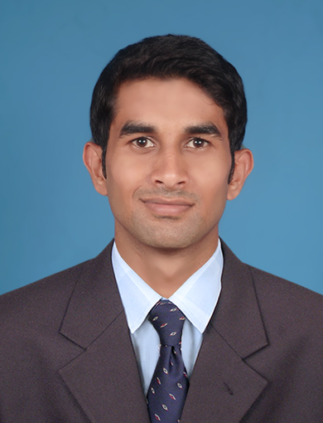
IMRAN ANWAR KHAN Mob: +971 522726199
Imran92khan90@gmail.com

Function: Handles all sales functions in a professional manner for counter customers by providing prompt and efficient service to achieve maximum sales and customer satisfaction.
Duties & Responsibilities:
- Exhibit a positive, friendly & helpful attitude with customers and be sensitive to their needs.
- Create sales order/enquiries.
- Maintain counter area displays of merchandise in an orderly and attractive manner.
- Assist and resolve customer’s complaints.
- Keeps abreast of new product information and upcoming product promotions.
- Receive payment or obtain credit information.
- Ability to exceed sales target on a regular basis
- Ability to handle multiple tasks
Professional work Experience:

Dollar rent a car UAE (Nov 2014-Till present)
- Dealing with customer enquiries about the availability and cost of vehicles.
- Taking bookings and explaining the terms of rental or leasing agreements.
- Worked closely with customers to make sure they understood their responsibilities.
- Responsible for answering incoming calls and arranging rentals for new clients.
- Handled customer’s disputes and tried to maintain customer confidence in the company.
- Completing paperwork with the customer and taking payments.
- Adhere to company quality assurance and uniform guidelines.
- Sells programs and services to customers in an effort to maximize sales opportunities and meet deals goals set by management.
Professional Work Experience:

Denave India Pvt. Ltd Company Bangalore, India :( May 2013- August 2014)
IT Sales Representative
- Handled the tasks of selling computer hardware as well as peripherals to customer and consumer.
- Sold various types of IT products like Tabs, Mobile phone, I pads,E-reader and accessories in TATA Company (CROMA ELECTRONIC MEGA STORE).
- Responsible for preparing status reports including follow-up and closings.
- Developed and implemented special sales activities to increase sales.
- Maintained and established relationship with current client and potential clients.
- Identified and resolved client's problems.
- Responsible for preparing proposals, presentations and sales contract.
- Identified sales prospect, makes preliminary contact with customers and introduced the company's product.
- Responsible for preparing monthly sales report and send it to the concerned sales manager.

Professional Work Experience:
Jakti Travels and Tourism-Karnataka,India(March 2012 to April 2013)
- Provides excellent customer service by assisting customers promptly and courteously with their requirements.
- Create sales order/Enquiries.
- Responds to inbound sales calls,responds to inquiries and provides information and or follow up.
- Assist and resolve customers complaint.

Education Qualification:
Bachelor of Commerce 2010 - 2013
Dr. A.V.Baliga College of commerce Kumta - Karnataka
Dharwad University, Karnataka - India

IT Experience:
Ms Office package, Outlook,Car rental Mangament system(CMS) & Mile power.
Tally ERP 9.0
Personal Profile
Name : Imran Anwar Khan
Sex : Male
Nationality : India
Date of Birth : 19/11/1992
Passport No. : J7054190
Driving license : 3762746
Marital Status : Married
Languages known : English, Hindi, Urdu & Arabic.

I Imran Khan declare that all the information given above is true to my Knowledge.

Place: Dubai
Yours sincerely
Imran khan

