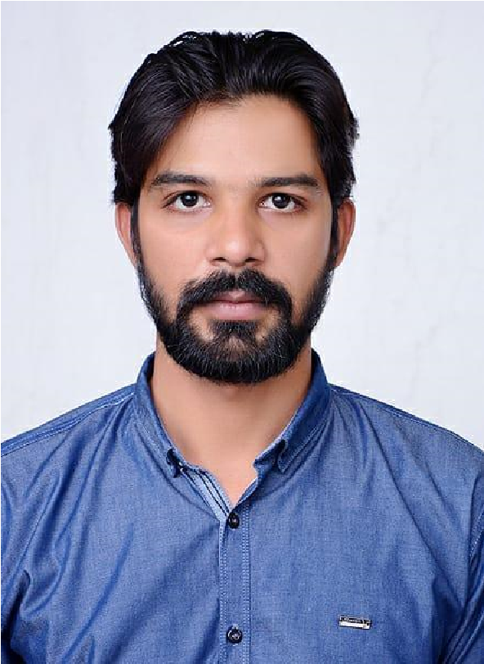
HIRAT KALEEM
Mob: +92-335-035-0661
E-mail
:
Hiratkaleem6@gmail.com
Career Objective
:
To
be
part
of
a
growing
organization
promising
growth
to
enhance
me
capacity
and
interpersonal
skills.
I
am
a
competent
person
with
diverse
experience
and
professional
background.
I
am
an
expert
in
Sales,
Marketing,
and
Digital
/
Social
Media
Marketing.
I
have
skills
and
abilities
to
work
under
pressure
to
meet
deadlines
individually
and
with
the
team
as well.
Professional Experience
Territory Manager Feb 2021— July 2022
Ilaan.com
Responsibility:
●
Organizing sales Visits
●
Demonstrating and presenting products
●
Establishing new business
●
Maintaining accurate records
●
Negotiating contracts and packages
●
Aiming to achieve monthly or annual targets
SALES EXECUTIVE
June
–Jan
2020
2018
Smart
Finance Commercial Broker LLC Dubai, Dubai
Responsibility:
●
Executed
locally.
Regional
and
national
marketing
and
branding
initiatives
to
drive
sales
within
existing
and prospective accounts.
●
Monitored trends in customer buying habits, market conditions and
●
competitor actions to adjust strategies and achieve sales goals
●
Targeted
new
markets
and
increased
sales
(
Number
)
%
through
proactive
sales
and
negotiation
techniques.
●
Enhanced
success
of
advertising
strategies
by
boosting
engagement
through
social
media
and
other
digital marketing approaches.
●
Attracted new clientele and developed customer relationships by hosting product-focused events.
●
Developed
strategic
relationships
with
existing
customers
while
conducting
cold
and
warm
calls
with
prospects.
Sales and
Marketing Executive
Aug
2013
–Feb
201
7
Zameen.com (Pakistan’s No.1 Online Property Portal) Responsibility:
- Developed and implemented favorable pricing structures balancing firm objectives against customer targets.
- Capitalized on industry and marketplace trends to strategize solutions and enhance business operations.
- Developed creative sales tools. Including presentations. Trend reports. Kilted assets, and product data sheets.
- Improved product marketing objectives by constructing communication initiatives and branding strategies to increase client outreach. Developed company brand messaging. Collateral materials, customer events, promotional strategies. And product commercialization.
Sale Executive Aug 2010 - Jan 2012
Sharaf DG Responsibility:
- Drove retailer engagement. Improved retailer satisfaction and earned retailer advocacy through communication and relationship management. Increased sales revenues services by leveraging effective negotiating skills.
- Targeted new markets and increased sales through proactive sales and negotiation techniques.
- Attended numbers (Number) retailer, distributor product, and sales training events to consistently increase product knowledge.
- Attracted new clientele and developed customer relationships by hosting product-focused events.
- Directed work of an efficient clerical team maintaining accurate sales. Inventory and order documentation.

Academic Profile
.
- Faculty in Arts – Punjab Board of Intermediate Education, Lahore
- Matriculation – (Majors: Science) from Imtiaz Public High School, Lahore

Skills and Abilities
- Computer literate with a good command over
- Microsoft Office and Internet Applications
- Can operate Photocopier, Fax, Scanner, and Printer etc.
Languages Spoken:
English - Fluent (Oral/ Written)
Urdu - Fluent (Oral/ Written)
Punjabi - Fluent (Oral/ Written)

Personal Information
Father Name | Kaleem Makhan
Date of Birth | 26th March1988
Nationality | Pakistani

REFERENCES
Will be furnished upon request

