**CIRRICILAM VITAE**

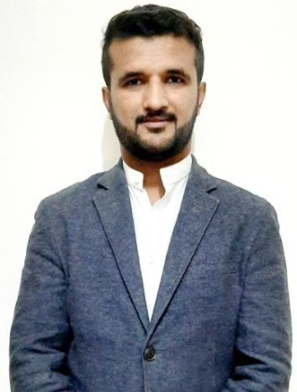 SYED HASEEB-UR-RAHMAN.

CELL NO: +923459234460/03005342484.

Email: [haseebrehman39@gmail/yahoo/outlook.com](mailto:haseebrehman39@gmail/yahoo/outlook.com).

Address : Warsak road ashiQ Abad pesh KPK

CARRERS OBJECTIVES:

* To work in professional environment where I can apply and enhance my knowledge by working in real world problems .To have hands on practicing the emerging technologies.

PERSONAL ATTRIBUTES:

* Requires minimum supervisions and ability to delivers under pressure.
* Warm, friendly and an outgoing personality.
* Team player with an open mind.
* Quick to learn and result oriented.

EDUCATIONAL BACKGROUND:

* Diploma of associate engineer. (**Technical board.)**
* Bachelor of Arts (political sciences. (**University of Peshawar )**
* HSSC pre engineering . (**Higher secondary board )**
* SSC Science Group. (**Higher secondary board)**

COMPUTER SKILLS:

* MS office and windows.
* Certificate of information technology.
* Typing and short hand.
* Hardware and software.
* Complete knowledge about AUTOCAD (CIVIL) 3D.

TEACHING BACKGROUND

* Student academy school Ashiq abad . (As computer & pak study teacher)
* Sham model school darmangi Peshawar. (As English & pakstudy & science )
* **GULF EXPERINCE :**
* As a sale supervisor in Dubai. **(Armada tech of wood LLC UAE** )
* As a site supervisor in telecom . (**Etisalate UAE )**
* As a administrator. (**Expert solution and services A.D** )
* **LANGUAGES**  : English , Urdu, Pashto (**fluent & written )**

**REFRENCE: can provided upon request**