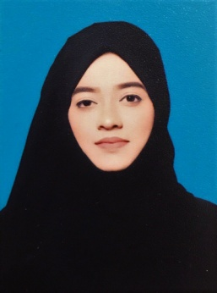

**CURRICULAM VITAE**

**FARHATH IHSHANA**

**MOB:** +971543616597

**Email:** farhathihshana@gmail.com

**OBJECTIVE**

Looking for a challenging and rewarding career.

**Work Experience:**

* **1 Year & 4 months experience as Executive Administrator in SMART LINE LOGISTICS ,UAE**
* **1 Year & 2 months experience as Administrator in Al Tahfiz Technical services ,UAE**
* **Experience as Marketing Executive in Gitex Technology week, UAE**
* **Experience as Freelance AutoCAD and 3Ds max Designer**

While working as **Administrator,** the following were my responsibilities:

* Handle confidential documents ensuring they remain secure
* Prepare invoices or financial statements and provide assistance in bookkeeping
* Monitor office supplies and negotiate terms with suppliers to ensure the most cost-effective orders
* Maintain electronic and paper records ensuring information is organized and easily accessible
* Conduct research and prepare presentations or reports as assigned

**Language skills**

Spoken : English, Tamil, Malayalam, Urdu and Hindi

Read & Write : English, Arabic and Tamil

**EDUCATIONAL QUALIFICATION**

* Senior Secondary Education conducted by Central Board of Secondary Education (CBSE), New Delhi.
* **Diploma in Interior Design.**
* **Bachelor’s Degree in BA (Honors).**

**TECHNICAL QUALIFICATION**

* **Proficient in MS Word, Excel and internet operations.**
* **Has a strong aptitude for AutoCAD, Adobe Photoshop.**
* Ability to work in a fast-paced, intense environment smoothly
* Skilled at interacting with customers of all socioeconomic backgrounds
* Work professionally with different departments to meet job profile

**OTHER QUALIFICATIONS**

* Has a flair for English Language and has good inter-personal skills
* Possess good temperament to deal with business environment
* Excellent verbal and written communication skills

**PASSPORT AND VISA DETAILS**

Passport Number : S9918949

Date of Issue : 18/10/2018

Date of Expiry : 17/10/2028

Place of Issue : Dubai, U.A.E.

Visa Status : Holding residence visa of UAE

**PERSONAL DETAILS**

Nationality : Indian

Date of Birth : 20-01-1997

Gender : Female

Address : Abu dhabi

**DECLARATION**

I hereby declare that the above mentioned particulars are true and correct to the best of my knowledge and belief.

Signed : 

______________________________________________