**D. DHILIPKUMAR**



**About Me**

**­**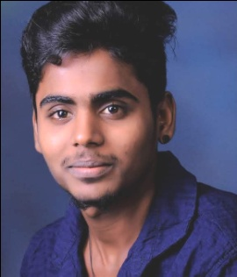



dhilip200595@gmail.com



May, 20, 1999



Villupuram, Tamilnadu



8190096864

**Objective**

To work a challenging in the environment in a reputed organization and to contribute the growth of the organization Through hard work and application.



**Education**

**DME (Mechanical Engineering)** Graduated, March 2018Venkatachalapathy polytechnique college Marks 81%  
Kappiyampuliyur, Villupuram   
Tamilnadu, India

**10+2** Graduated, March 2016Government Higher Secondary School Marks 74.5%  
Tamilnadu Stateboard Board   
Valavanur, Villupuram

**10**

Government Higher Secondary School Graduated, March 2014   
Tamilnadu Stateboard Board Marks 63%  
Valavanur, Villupuram



**Skills**

* Leadership skills
* Assembling
* Easily Adoptable
* Quality
* Positive Attitude



**Computer Proficiency**

* Word 2010
* Excel 2010
* Power Point 2010



**Languages**

* Tamil
* English



|  |  |
| --- | --- |
| * Gardening | * Caring Animal |
| * Music | * Reading |
| **ExperiencePersonal Interests** |  |

­

* Worked in production department from **MAY-2018** to **May-2019** in **PYUNG HUA INDIA PRIVATE LTD** sriperumpudhur.
* Worked in production department from **JUN-2019** to **JUN-2022** in in **LUCAS TVS PVT LTD** Pondicherry.
* Now Working in ZOMATO as a delivery boy From Apr-2023 to till now.



**Personal Details**

Father’s Name: Mr. Dhandapani Marital Status: Single  
Birthday: May 20, 1999 Nationality: Indian  
Gender: Male

**Address**

23, Thiruvalluvar Nagar, Valavanur 605108

**Declaration**

I,am Dhilipkumar, hereby declare that the information contained herein is true and correct to the best of my knowledge and belief.

____________________________  
D.Dhilipkumar Villupuram, Tamilnadu