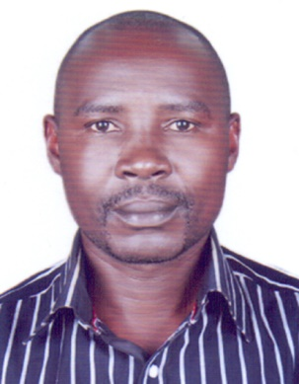**CURRICULUM VITAE**

KAWOOYA DAVID

Abudhabi-UAE

Mobile: +971551868540

Email: kawooyadavid54@gmail.com

**APPLICATION FOR HOUSE KEEPING ATTENDANT**

**OBJECTIVE.**

Seeking a position as a House Keeping with utilizing exceptional hospitality skills, and ability to provide prompt and courteous service to the patrons in order to maximize Revenue and Customer satisfaction.

**PERSONAL DATA**

Nationality : Ugandan

Gender : Male

Passport No : B1401860

Visa status : Employment Visa

Language : English

**WORK EXPERIENCE**

I have 2 years worked experience as **HOUSE KEEPING** at **NIAGARA HOTEL** in Uganda and 1.5 years worked experience as a CLEANER at ME SERVICE LLC Abudhabi.

**ADDITIONAL SKILLS**

* Excellent communication skills
* Dependable, accountable, honest and hard-working
* Able to follow directions timely and accurately
* Working knowledge of cleaning tools and appliances
* A cheerful disposition and eagerness to work in fast-paced environments
* Demonstrated ability to greet patrons, present menus, make suggestions and reply questions
* Hands-on experience in taking orders and relaying to kitchen and bar staff
* Proven record of preparing and serving specialty foods at tables  
  Able to assist guests in menu selection, and provide accurate and detailed information

|  |  |
| --- | --- |
| **CORE COMPETENCIES** |  |
|  |  |
| * Team player, Self Motivated |  |
| * Good Communication skills |  |
|  |  |
|  |  |

**DUTIES JOB RESPONSIBILITIES:**

* Changed bed lines and collected soiled lines for cleaning
* Disinfected and mopped bathrooms to keep them clean.
* Collected trash and moved garbage cans from kitchen areas to pick-up stations.
* Returned emptied garbage receptacles to their proper locations.
* Cleaned walls, windows, shades and curtains.
* Used chemicals and other cleaning equipment’s in a proper, safe and responsible manner.
* Cleaned and changed bedspreads, blankets and mattresses.
* Verified that all storage areas and carts were clean and organized.
* Swept and washed all hard surface floors.
* Moved chairs, desks and beds around rooms to clean behind and underneath them.
* Weep, scrub, mop and polish floors
* Vacuum clean carpets, rugs and draperies
* Shampoo carpets, rugs and upholstery
* Dust and polish furniture and fittings
* Clean metal fixtures and fittings
* Empty and clean trash containers
* Dispose of trash in a sanitary manner
* Clean wash basins, mirrors, tubs and showers

**EDUCATION**

High School Education

|  |  |
| --- | --- |
| **REFERENCES** |  |

Available on request.

**DECLARATION**

**I hereby declare that all the information’s furnished above are true and correct to the best of my knowledge and belief**