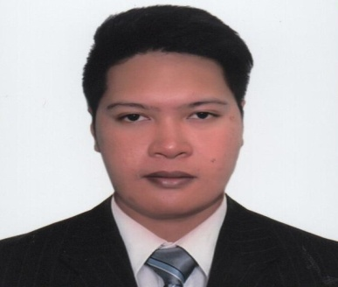**DAN DAVE D. ALCANCIA**

Address: Main Street, Al Ain, UAE

Contact information: 0527283279

Email Address: [ddalcancia@yahoo.com](mailto:ddalcancia@yahoo.com)

Visa Status : Visit Visa

**CAREER OBJECTIVE**

To pursue a highly rewarding career, seeking for a job in challenging and healthy work environment where I can utilize my skills and knowledge efficiently for organizational growth.

**WORKING EXPERIENCE**

**Strong Motors Co. (Abu Dhabi, UAE)**

**Telemarketing cum Outdoor Sales , APRIL 2015 –APRIL 2017**

* Contact businesses and private individuals by telephone to promote products and services
* Explain the product or service to potential customers
* Deliver scripted sales pitch to the customer
* Handle customer questions
* Obtain customer information including names and addresses
* Obtain contact details of potential customers from sources including telephone directories and purchased lists
* Schedule appointments to meet prospective customers
* Answer telephone calls from potential customers who are responding to advertisements
* Contact customers to follow up on initial interaction

**OJT EXPERIENCE**

**Stream Global Services/IT Support**

Makati City, Philippines

November 2013 – February 2014

* Deliver service and support to end-users using and operating automated call distribution phone software, via remote connection or over the Internet
* Interact with customers to provide and process information in response to inquiries, concerns, and requests about products and services

**ACADEMIC QUALIFICATIONS**

**Bachelor of Science in Information Technology**

**Lyceum of the Philippines University - Batangas**

Capitol Site, Batangas City

2010-2014

**SECONDARY**

**St.Mary’s Educational Institute**

Ilustre Avenue,Lemery Batangas

2006-2010

**PRIMARY**

**San Luis Central School**

2000-2006

Poblacion, San Luis ,Bantangas

**PERSONAL INFORMATION**

Nickname : Dave

Birthday : October 6, 1993

Place of Birth : Poblacion, San Luis, Batangas

Age : 25 years old

Gender : Male

Civil Status : Single

Language Skills : English, Filipino

*References available on request*

**DAN DAVE D. ALCANCIA**

Name of Applicant