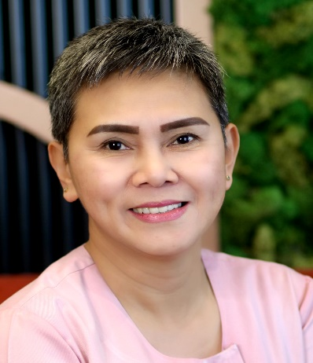 |  | Cristina Pereja Bondoc  Receptionist / Cashier
Contact  Mobile Number:  0508874657  ADDRESS:  Al-Rigga Street, Deira Dubai,  United Arab Emirates  EMAIL  bondoccristina@yahoo.com  tengbondoc25@gmail.com |  | EDUCATION  Polytechnic University of the Philippines  1987 – 1991  BACHELOR IN TOURISM  WORK EXPERIENCE  April 25, 2021 – October 12, 2023  Mason Monaco Ladies Salon  Dubai, UAE  Position : Facial Therapist / Receptionist /Basic Pedicure  July 3, 2019 – December 30, 2020  Newlook signature ladies salon/spa  Dubai , UAE  Position : Facial Therapist / Receptionist  August 20, 2016 - March 30, 2018  The Loft Fifth Avenue Salon  Dubai , UAE  Position : Facial Therapist  December 10, 2005 – April 22, 2016  Cocoon Spa and Health clinic  Al – ain, UAE  Position : Facial Therapist / Swedish massage therapist  SKILLS  Well known, on how to handle this following machines for facial :  FACIAL MACHINES: Skin master max, ultrasound, ultrasonic, micro-dermabrassion ( crystal or diamond peel ), galvanic, high-frequency, bio-light therapy, oxy-mega station with infusion, steamer, infrared, rf and hydra-facial , sorisa photo care, sorisa skin light machines, fusion 3d machine.

