AJITH PRIYANKARA

***Videograhy & Photography Expert***

055 903 6545

[vmixproduction@gmail.com](mailto:vmixproduction@gmail.com)

104, Al Hameed Building, Rawdha 03, Ajman.

**EXPERIENCE BEHIND CAMERA**

# PERSONAL DATA

Age: 48 Gender: Male

Nationality :Sri Lankan Married

# EDUCATION

GCE ADVANCED LEVEL- 1995-PASS

GCE ORDINARY LEVEL- 1993-PASS

# SKILLS

Creativity Computer Language Team work

# VISA STATUS

Visit visa

Vakid till 12th Jully 2024

# LANGUAGES

English - Good Sinala - Native

**Videographer (Cameramen) -** VMAX Productions - Sri Lanka 25 Years’ Experience

* *Operated various types of cameras (digital, film, handheld) for television broadcasts, film shoots, and live events.*
* *Collaborated with directors and technical crews to achieve desired visual effects and camera angles.*
* *Maintained and handled high-value camera equipment, ensuring optimal performance and longevity.*
* *Assisted in setting up and breaking down camera equipment before and after shoots.*
* *Utilized lighting techniques to enhance visual storytelling.*
* *Edited footage using software like Adobe Premiere and Final Cut Pro to produce polished final products.*
* *Conducted live video streaming and recording for events, ensuring high-quality transmission*

# Photographer

* *Conducted photoshoots for various clients, including individuals, families, and businesses.*
* *Specialized portrait, wedding, commercial and outdoor events*
* *Edited and retouched photos using Adobe Photoshop and Lightroom.*
* *Managed client relationships, ensuring satisfaction and repeat business.*
* *Coordinated with other professionals (stylists, models, makeup artists) to achieve desired results*

**Studio Operator -** Tricast Studio - Sri Lanka 03 Years’ Experience

* *Operated and monitored studio equipment, including cameras, audio mixers, and lighting systems, ensuring smooth production of live and recorded broadcasts.*
* *Coordinated with directors, producers, and on-air talent to facilitate seamless communication and execution of production plans.*
* *Conducted regular maintenance checks on studio equipment, troubleshooting and resolving technical issues promptly to minimize downtime.*
* *Managed studio setup and teardown for various productions, including news broadcasts, talk shows, and special events.*
* *Ensured adherence to technical standards and compliance with broadcasting regulations.*
* *Trained and supervised junior operators and interns, providing guidance on equipment operation and studio protocols.*
* *Implemented and maintained studio workflows to enhance efficiency and improve production quality*

# PORTFOLIO

**Photography**

https://drive.google.com/drive/folders/1opa39WJNQh_wARGk5BeD5WVNUUfl3IAy?usp=drive_link

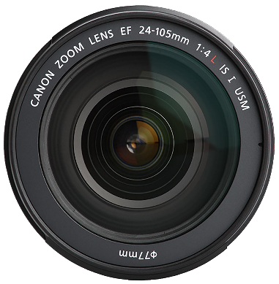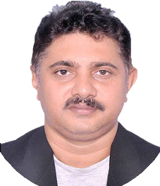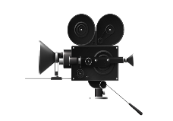

**Videography**

https://drive.google.com/drive/folders/1FbO1Iw2Zpt_O2uuctB1gpY_BJ24bfHXl?usp=drive_link