**CURRICULUM VITAE** 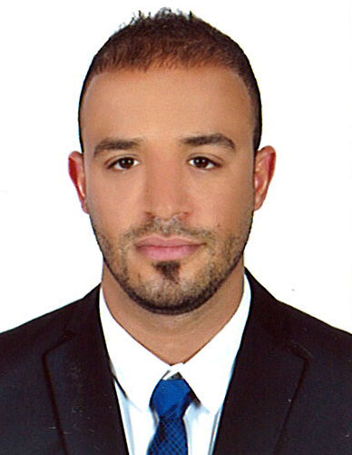

**Address: Abu Dhabi, U.A.E**

**Mobile No. 050 – 5200694**

**Email Add.: halimmeslim@gmail.com**

**Objective:**

To be able to join the company on any qualified position where my skill and qualification requires meet or exceed organization goals.

**Personal Information:**

Name : Abdelhalim Sadok

Date of Birth : 27/09/1987

Place of Birth : Morocco

Nationality : Moroccan

Gender : Male

Visa Status : Residence Visa

**Driving License Details:**

License No : 2151360

Place of Issue : Abu Dhabi, UAE

Date of Issue : 02/02/2014

Date of Expiry : 01/02/2024

**Educational Qualification:**

* High School Certificate.

**Languages:**

* Arabic
* English
* French

**Work Experience:**

**Working as a Supervisor in Di**

**roma Café , Abu Dhabi for 04/10/2014 up to present.**

**Job and Responsibilities:**

* To set and maintain, the highest standards of customer service in the cafe to provide cover with the other staff as required on a daily basis, (i.e. lunch cover).

* Stock takes at regular intervals with the assistance of the management team to work with the management team, on purchasing and other projects as required.
* To ensure good timekeeping and performance by staff, and to comply at all times with the security procedures and uniform for staff as instructed to assist the Go Ape management team, to maintain the standards of hygiene and health and safety at all times and throughout all the catering operations.

**Worked as a Sales Executive in caffee and restaurant , Abu Dhabi for 2 years.**

**Job and Responsibilities:**

* Represent the Company in the market.
* Develop and increase Company’s business.
* Prepare customer quotations and presentations in line with campaigns for services current pricing and conditions.
* Prepare reports on a daily, weekly and monthly basis as requested by management.
* Assist and support customer debt collections and any other duties which will be assigned by the management.

**Worked as sales in Morocco mall,**

**for 2 years.**

**Worked in sales marketing , Abu Dhabi for 3 years.**

**Job and Responsibilities:**

* Manage front desk operation which includes but not limited to, staff scheduling, training, inventory etc.
* Resolve all guest/member complaints, to ensure guest satisfaction.
* Provide information and assistance to all staff and guests.
* Perform openings and or closing procedures as necessary.
* Assist with administration duties such as payroll, scheduling, forecasting, stock taking and orders.

**Personal Skills:**

* Ability and willingness to learn more whist working on the job.
* Excellent communication and self correspondence skills.
* Dedicated with the strong interpersonal skills.