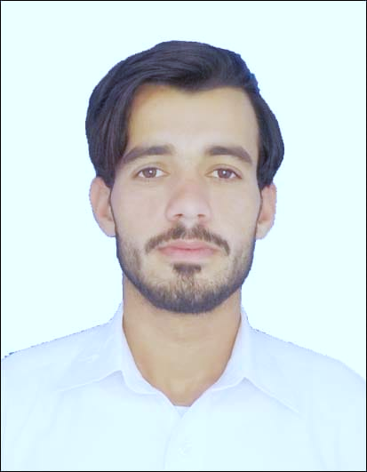

**Shah Zeb Khan**

**Address:**Abutina sharjah UAE

**Email:** shahzaibkan67@gmail.com

**Mobile:** 0508287300

**Whatsapp**:00923149121567



**Career Objectives:**

* To be able to develop further my skills and to exhibit what I’ve obtain from my academic years.
* To excel in my field through hard work and perseverance and to serve your company with the best of my abilities.



**Personal Background:**

Born : 20 March 2002

Gender : Male

Age : 19 yrs/old

Religion : Muslim

Civil Status : Single

Passport no : RV4143021

Nationality: Pakistani



Tertiary : Hira public school (KPK)

(Year 2016-2017)

Secondary : Orbit Degree collage (KPK)

(Year, 2018-2020)

**Sale Representative:**

* Greet and talk to customers in a courteous manner.
* Handle inbound calls from customers.
* Assist customers in locating the merchandise they need.
* Answer and respond to customer inquiries regarding merchandise.
* Prepare list of items to be re-stocked.
* Assist customers in completing the purchases.
* Handle refunds, returns and exchange of merchandise.
* Maintain and manage store room neat and tidy.
* Follow check list after opening and before closing the shop.

**Work Experience:**

**MCB BANK:**

**Work in MCB bank as a accountant for 1 year.**



**Skills:**

* Computer literate.
* Capable of communicating in English, Basic Arabic and Korean language.
* Pleasant, responsible and flexible.
* Works well under pressure.
* Hard-working and reliable.
* Goal-oriented.
* Friendly and outgoing.
* Willing to learn and undertake training if necessary.



**Personal Reference:**

Available upon request

I hereby certify that the above information are true and correct to the best of my knowledge.

**Shah Zeb Kahn**

*Signature*