9074563003| [amalbhaskar2017@gmail.com](mailto:amalbhasker2017@gmail.com) Vellarulli ,Nadakkuthazha (Po), Kozhikode - 673104

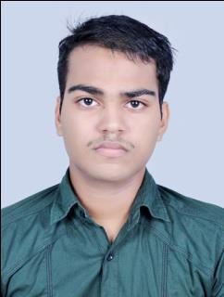

# E D U C A T I O N

AMAL BHASKAR.V

A well presented, polite, tactful and friendly individual who is able to combine a polite

manner with razor-sharp efficiency

2018

# B.Com Computer Application Calicut University

2015

2013

**T E C H N I C A L P R O F I L E**

**SENIOR** **SECONDARY** **EDUCATION** **(** **12** **TH** **)-** **COMMERCE**

Kerala Higher Secondary Examination Board, India 59Percentage

# SSLC

Kerala Board of Public Examinations 64Percentage

# T E C H N I C A L S K I L L S

* **CERTIFICATE** **IN** **ACCOUNTING** **TECHNICIAN** **(** **CAT)** **[ INSTITUTE OF COST ACCOUNTANTS OF INDIA]**
* **6 MONTHS WORKING EXPERIENCE AS A MARKETTING MANAGEMENT TRAINER, AYUR CARE**

# L A N G U A G E S K I L L

* TALLY.ERP 9
* MICROSOFT EXCEL
* BASIC COMPUTER KNOWLEDGE
* G S T FILING RETURN

# P E R S O N A L D E T A I L

* Malayalam
* English

# DECLARATION

Gender : Male

Date of Birth : 21th MAY 1997 Nationality : Indian

Religion : Hindu

Marital status : Single

I hereby declare that the above mentioned information is true to the best of my knowledge.

# AMAL BHASKAR.V