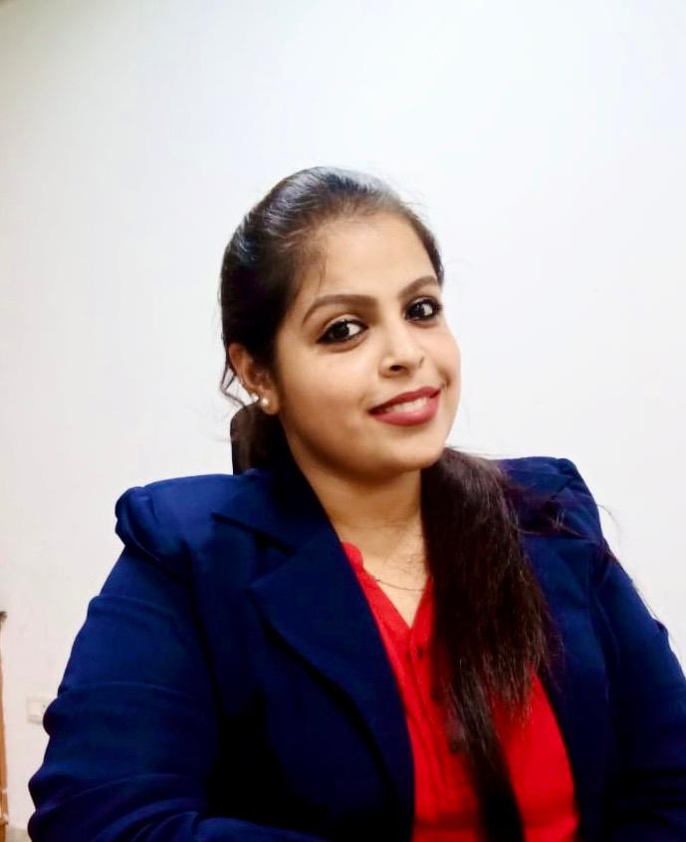

**Zuman Zanbakh MP**

**Medical Event Manager- IML**

**+971555640696 |** **zanuzims@gmail.com**

**Ras Al-Khaimah, UAE**

**Objective:** Challenging and rewarding position in growth oriented organization, offering diverse job responsibility to improve and fully utilize my skills and knowledge to growth along with the organization objective

**Education:**

* 2013- 2017: **UG- Bachelor of Technology in Biomedical Engineering** **CGPA 9.18**

Rajiv Gandhi College of Engineering & Technology, Pondicherry, India

(Deemed to Pondicherry University)

* 2011- 2013: **Secondary School – Group 1 BCM**  **90%**

Mubarak Higher Secondary School, Thalassery, Kerala

* 2011: **SSLC**  **94%**

St. Theresa’s Higher Secondary School, Mahe, Kerala

**Experience Summary:**

* **Scientific Relations Associate**: Omics International Pvt. Ltd, Hyderabad, India July 2017- January 2018
* **Team Lead (Medical Events):** PULSUS Health Tech LLP, Chennai, India February 2018- May 2020

**Skills:**

* Efficient Content Writing
* International Website Development
* Quality Checking for the contents
* Medical Marketing team leadership
* Medical Marketing expertise
* Marketing techniques knowledge
* Online marketing strategies
* Production team motivation
* Coordinating team projects
* Team Training & guidance
* Teamwork and contribution
* Team recruiting

**Work History:**

* Guided 63 enthusiastic program associates in lead role in the field of medical event management
* Prepared efficient contents for international websites
* Developed medical, technical and scientific contents and constructed website
* Quality analysis and ensuring quality assurance for the contents
* Prepared detailed reports on updates to project specifications, progress, identified conflicts and team activities
* Developed monthly and daily production output plans to deliver on customer service and financial metrics
* Evaluated employee skills and knowledge regularly, providing hands-on training and mentoring to individuals with lagging skills
* Tracked receipts, employee hours and inventory movements
* Trained new program associates by relaying information on company procedures, safety requirements and targets and delivered constructive criticism upon completion of job tasks
* Established open and professional relationships with team members which helped resolve issues and conflicts quickly
* Designed strategic plan for component development practices to support future projects
* Individually trained to be an efficient medical event manager by building scientific relation with the highly eminent personals across the globe
* Managed to be the onsite event manager for 20 international medical events
* Supported the HR team for recruitment requirements

**Certifications:**

* Certified for attending workshop on **Advanced Bio-Medical Instruments–Impulse’15**, training provided a detailed introduction about the equipments
* Certified for Participation in the **Zonal Round Of Robotryst -2016**, organised by Robosapiens Technology Pvt.Ltd ,IIT-Delhi
* Certified for attending workshop on **Big Data, Robotic Satellite Programming & Pcb Design** conducted by International Science & Research Organization
* Certified for **Qcad Training Provided By Spoken Tutorial** Project, IIT –Bombay
* Certified for participation in **Robowar** conducted by E-CLAN’16 held at RGCET, Puducherry
* Certified for attending workshop on **Critical Care Equipments** in association with Biovision held at RGCET, Puducherry
* Certified for attending workshop on **Medical Equipment Management** organised by Shri Swastic Academy at RGCET, Puducherry

**Personal Detail:**

* Date of Birth : 07 May 1995
* Nationality: Indian
* Visa Status: Spouse Visa
* Languages:
  + English (Speaking fluency, read & write)
  + Malayalam (Speaking fluency, read & write)
  + Tamil (Speaking fluency)
  + Hindi ( Read & write)
  + Arabic ( Read & Write)

**References available upon request**