Dyaral Ferrao

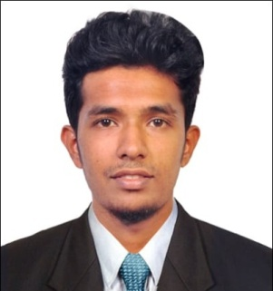**Address** Burjuman, U.A.E.

**Phone** +971543854109

**E-mail** [dyaral450@gmail.com](mailto:dyaral450@gmail.com)

**Date of birth** 05-21-1994

**Passport Number** P5958750

**Nationality** Indian

# Career Objective

To develop and discover my vision into pragmatic action, as a performance-oriented official of proper accounting track record, I want to activate my “self-branding” strategy in your organization with strong and healthy confidence.

# Work experience

## Apr 2018 to Aug 2020 Perfect Concrete Products FZC

Accounting Assistant

Developed a cross-check functionality in excel to pick up on any human errors relating to manual data entry resulting in marginal error rates decreasing from 25% to only 3%.

* Complete complex calculations and reconcile problematic accounts.
* Handling daily bookkeeping functions and reconciling account ledger.
* Answering phone calls and emails and resolving customer's queries.
* Drafting letters and requesting check for overdue accounts.
* Managing spreadsheets, journals, and sales and purchase ledgers.
* Fixed asset accounting, reconciliations and depreciation journals.
* Inputting of supplier invoices and employee expense claims to the ledger.
* Conduct payroll administration for all employees in terms of pay rates, social security numbers, and bank account information.
* Reviewed general ledger entries and assessed accuracy.
* Preparation and filling of VAT Return.

## Oct 2015 to Oct 2016 Rao & Basri Chartered Accountants

Accounting Assistant

* Process accounts payable and accounts receivable transactions and reconcile them.
* Re-check all account reconciliations before drafting the income statement, balance sheet, and cash flow reports.
* Managed petty cash transactions on a daily basis.
* Deposited cash and check in bank and made entries in the computer system.

# Education and qualifications

## Aug 2015 to June 2017 St. Aloysius College

Master of Commerce

## June 2012 to June 2015 Rosario College of Management Studies

Bachelor of Commerce

# Skills

Microsoft Word Intermediate

Microsoft Office Intermediate

Tally ERP Intermediate

Outlook Expert

Bookkeeping Expert

Payroll Processing Expert

Finance Intermediate

English Expert

Hindi Expert

Kannada Native

Konkani Native

# Interests and hobbies

Cricket, Music, Traveling.

**Declaration**

I hereby declare that all the above details are true, complete and correct to the best of my knowledge.

Date : 12.09.2020

Place : Sharjah

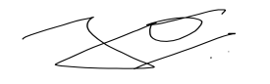

(Dyaral Ferrao)