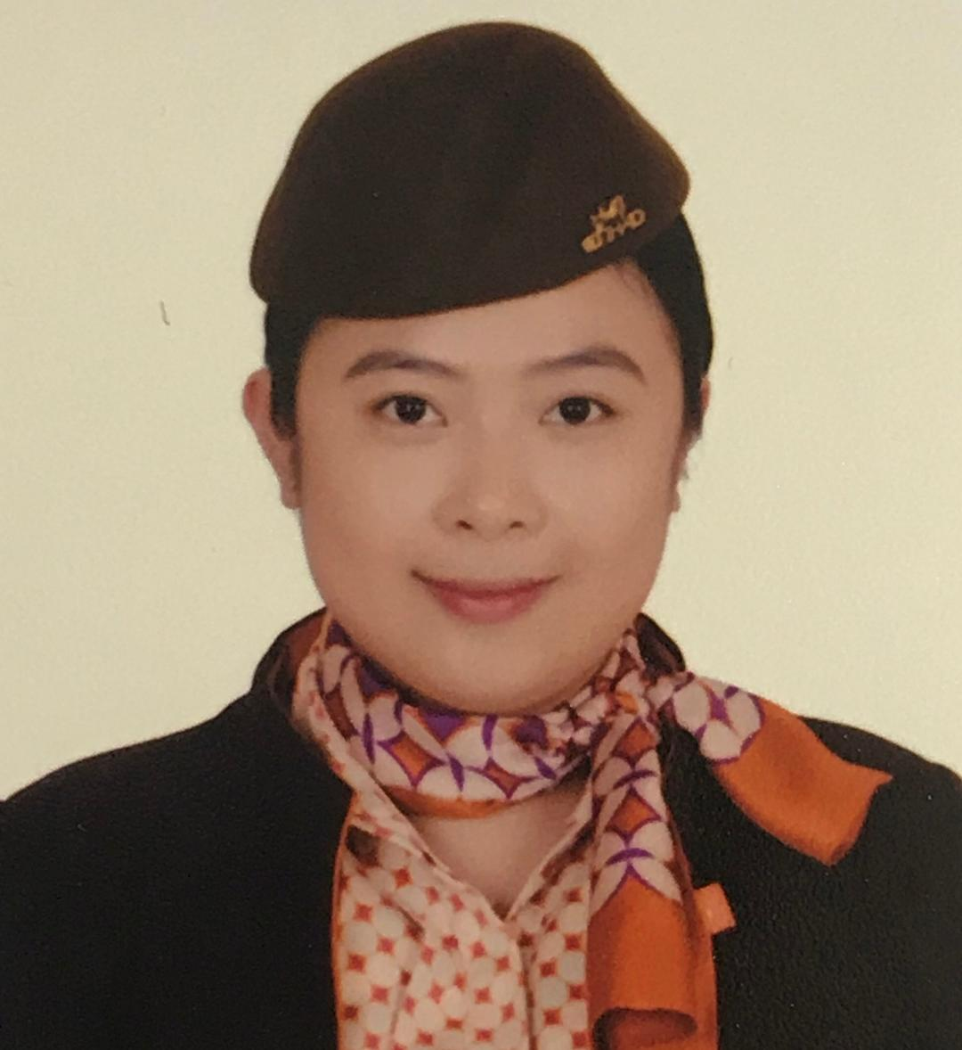

**Katrin Jean B. Basabe**

902 Lifco Building Al Zahiyah st.

Abu Dhabi, UAE

Contact no.: 0555813263

E- mail: [kj.basabe@yahoo.com](mailto:kj.basabe@yahoo.com)

**OBJECTIVE**

* To further broaden my knowledge and expand my horizon, and to be of any help to the people of these goal-oriented organization.
* To contribute my best in a company by imparting my skills and talents reshaped by experience and sharpened by activities.

**JOB EXPERIENCE**

December 3, 2012- Present **Etihad Airways**

Position: Guest Service Agent

* Provides assistance to our valued guests at check-in counters
* Transfer operations - ensuring seamless transfer of guests from arrivals onto subsequent departure flight
* Actively participating in the business exercises/trainings
* Participated in the company’s budEY program (training and supporting newly hired staff)
* Participated in making training flights for the new (Midfield) terminal
* Performed duties at boarding gate such as announcements, boarding guests, preparing documentation needed for the flight
* Achieving on time performance on each flight assigned to
* Generate ancillary revenue transactions
* Handling denied boarding guests in professional manner
* Playing a dynamic role during flight disruptions (weather, aircraft technical and operational delays)
* Assigned on Special Services team where we accommodate our premium guests and other meet and greet assignments
* Facilitate in the process of the US Customs and Border Protection in the airport
* Liaising with US CBP officers to ensure smooth operation

July 5- October 7, 2012 **Etihad Airways**

Position: Temporary Guest Service Agent

**TRAININGS AND SKILLS**

* **DCS-RTB Basic Check-in Training**
* **Hallmark of Excellence (Customer Service Training)**
* **Product and Services Training**
* **SabreSonic Passenger Services Systems Training Course**
* **Winning Through Guest First Training**
* **Emergency Response Plan**
* **Macro System training**
* **Maestro Systems course**
* **Microsoft Office**
* **Basic Web Design**
* **Basic Web Animation**

**QUALIFICATIONS**

* Easily develops communication skills
* Ability to work under pressure
* Good public relations personality
* Dedicated, diligent, hardworking, fast learner
* Extremely motivated for career goal
* Creative Writing
* Fast typing skill
* Superior knowledge in English language both written and oral
* Works in a confident and enthusiastic approach
* Ability to multi-task
* Able to adapt to different situations and change
* Able to work independently with the initiative to do things that may benefit the company

**EDUCATION**

COLLEGE **St. Paul University Quezon, City** (March 2011)

Bachelor of Arts in Mass Communications, Major in Digital Media

HIGH SCHOOL **Siena College Taytay** (March 2007)

**PERSONAL DATA**

Age: 30 years old

Date of Birth: April 11, 1990

Place of Birth: Naga City, Camarines Sur Philippines

Citizenship: Filipino

**CHARACTER REFERENCE**

Available upon request