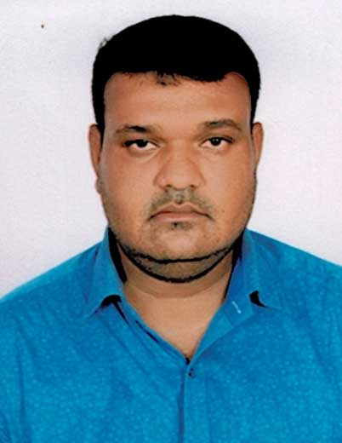
CURRICULUM VITAE

Jafar Mohammed

Mob: 00971 568101330

Emai: jafarmomheed@gmail.com

Dubai UAE

Application For: Cleaner

Objective:
Intend to build a career with the leading corporate of hi – tech environment with committed and dedicate people, which will help me to explore myself fully and realize my potential. Willing to work as a key player in challenging and creative environment.
Skills:
- Able to work individually and as team.
- Hard working committed and result oriented capable of working independently.
- Accommodative attitude blended with keen sense of responsibility and leadership and willing to learn.
- Effective organization skills with planning, coordinating and leadership and controlling capabilities.
- Able to work under pressure with minimal supervision.
Work Experience:
- Presently working in Idaama Facility Management Solutions Dubai UAE as a Cleaner .from June 2018 to till date
- 1 year worked as a Cleaner in Transguard Group Dubai UAE
Education Qualification:
- High School
Passport Details:
- Passport No : P5755733
- Date of Issue : 28-11-2016
- Date of Expiry : 27-11-2026

Duties & Responsibilities:
- To come on duty with complete uniform and well groomed.
- Check / clean the designated section.
- Replace any soiled linen to fresh one.
- Complete all the amenities in the area.
- Check and report / follow up any maintenance while on duty.
- Report any lost and found in the section.
- Follow team leader / manager instruction related to work.

Personal Profiles:
Name : Jafar Mohammed
Date of Birth : 01-01-1982
Nationality : India
Religion : Muslim
Gender : Male
Marital Status : Marriage
Languages Known : English, Hindi & Telugu

Conclusion & Declaration:
I hereby declare that the above details furnished by me are true to the best of my knowledge and belief.

Place: Dubai Jafar Mohammed

