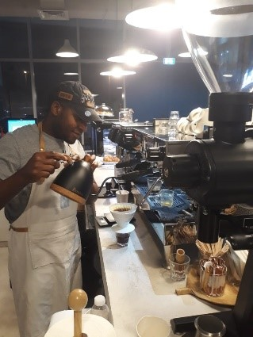**Name**: achooh linus nkeng

**NATOINALYTY**: Cameroon

**Email**: nkenglinus99@gmail.com

**Contact Number**: +971586540744

**Instagram page** (linus-nkeng)

**Commitment**: can join immediately

**♦♦♦ HEAD BARISTA / SUPERVISOR ♦♦♦**

**Professional Summary**

Barista knowledgeable in all aspects of coffee shop operations including impeccable customer service, staff management, supply ordering and creating a warm, welcoming environment.

**Skills**

* Custom beverage creation
* Team player . Latte art
* Good understanding . Employee training
* Menu design . Customer service
* Excellent memory . Strong communication skills
* Exceptional customer service  **.** Culturally sensitive
* Opening and closing duties . Computer proficient
* Highly organized . Smoothie making
* Quick learner . Friendly and outgoing
* Flexible schedule . Highly observant
* Cash handling

**Work History**

**Seventh Avenue Café and Restaurant United Arab Emirates**

**Head Barista/Supervisor**

**February 2020 - Present**

* Design new menus as the seasons and local tastes change, ultimately memorizing and serving more than 32 made-to-order options at any given time.
* Explain weekly and seasonal specialties to customers and recommend other menu options, serving an average of 300 guests each day within a 9-hour window.
* Prepare and serve customers biscotti, pastries and other coffee house treats in the bookstore’s cafe area and counter.
* Clean tables, dishes and the rest of the cafe after closing each day to ensure it is ready for opening again the next morning.
* Supervises and manages the coffee preparation.
* Addresses all issues, concerns, and complaints from customers.
* Reviews and gives recommendations on improvements to the coffee shop
* Ensures cleanliness of the coffee shop.
* Educate customer of different coffees and their brewing ratios for consumption.
* Audits and inspects safety, working condition and maintenance of all equipment.
* Prepares required reports and paperwork, preparing and serving a variety of **coffee** drinks, along with pastries and cookies.

**The Blue Door Café United Arab Emirates**

**Head Barista**

**February 2018 – January 2020**

* Prepped the coffee house for service each morning by setting up tables, grinding fresh coffee beans and preparing equipment for the day's operations.
* Assisted other team members whenever necessary in preparing and plating a number of pastries and pre-made sandwiches.
* Cleaned the tables and equipment after closing each day before packing up any leftover pastries for donation to the local soup kitchen.
* Assisted in designing new signature drinks each week and promoting specialty beverages that strategically utilized excess coffee beans and other ingredients.
* Prepared custom hot and cold beverages on request while memorizing a menu of over 70 made-to-order drinks.
* Greeted and served more than 200 guests each day, offering both counter service.
* Go orders and table service for sit-down customers.

**Café Rider custom coffee roastery United Arab Emirates**

**Senior Barista**

**March 2016 - November 2017**

* Promoted a line of retail products that the cafe sold, including various coffee roasts and mugs, while educating customers on their purchases of coffee-making equipment.
* Prepares all types of house beverages from coffee, tea to hot chocolate.
* Manages and oversees all brewing equipment.
* Manages food preparation area.
* Conducts end of day and end of month inventory.
* Reviews par stock levels of coffee shop.
* Maintains cleanliness of the coffee shop and roastery
* Opens/closes coffee shop.
* Attends to requests, comments, and concerns from customers

**Education**

**High school diploma**

**Advance level certificate**

**Bachelor degree**

**Additional Information**

* Member of the Specialty Coffee Association.
* UAE Driver’s license.
* Food Safety Certificate.