BIODATA

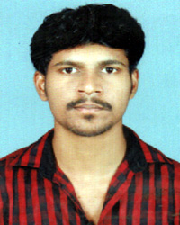
Jyothish M
Mottemmal House,
Narippatta Post,
Kallachi Via, Kozhikode Dist,
673506.
Mob : +91 9847722739, +91 9048658339
Email : jyothishmnpt@gmail.com

Objective
To utilize my skills and knowledge to grow professionally and intellectually and thereby make a positive contribution to your organization.

Academic Achievements

- SSLC
- PLUS TWO

Personal Details
Name : Jyothish M
Fathers Name : Radhakrishnan M
Date of Birth : 14th January 1993
Nationality : Indian
Religion : Hindu
Gender : Male
Marital Status : Single
Languages Known : English, Malayalam
Blood Group : O + Ve

Professional Qualification

- Diploma in Computer Application [Kerala Government]

EXPERIENCE

- Worked as a Store Manager in Britannia Industries Pvt.Ltd.
- Worked as a Office Assistant in Kozhikode District Co-operative Hospital
- Currently working as a Store Manager in Kuttipuram Supermarket

Assurance
I take the job with a great sense of responsibility enjoy the challenge of the new situation and expect to make positive contribution to your organization.

Jyothish M

