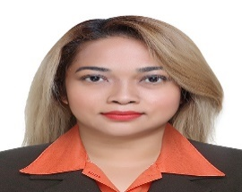  Information  murillo.m18@yahoo.com  +63 9615105635  28-1A Blumentritt St. Naga City  Skills  - Hair coloring  - Hair cut  - Hair styling  - Manicure and pedicure  - Customer service  - Good in selling  - Inventory and stock keeping  Objective  Technically expertise and well trained hair stylize and cosmetologist. With update of trends  .  award  2019 best asst. hairstylist for best employee of the year.  2018 best asst. hairstylist for best seller of the year. | MARIA HAZEL NEOLA  murillo  Experience  asst hairstylist • tips and toes uae•2015 – 2020  - With expertise of performing blow dry  - Hair coloring  - Basic hair cut  - Hair style  - Asst. master hair stylist if have back to back clients.  - Recommending home care product  Manicurist and pedicurist •tips and toes u.a.e• 2014 – 2015  - Nail care  - Foot spa  - Hands feet’s treatment  - Recommending home care product  SALON OWNER ANGEL TOUCH SALON AND SPA NAGA CITY PHILIPPINES 2009 -UNTIL PRESENT  - With my training and education, started my own saloon in our neighborhood and successfully established the salon with passion and professionalism.  Education  hotel and resturant management• 2003 •  It’s a 2 years course with the details study of hotel operation w/ customer service.  secondary education•2001• milaor high school  My basic education.  training and seminar  - Trained in Beauty Care TESDA – kolping society- Philippines  - Trained in Cosmetology-University of Santa Isabel-Philippines  - Trained in Hair Science- UAE  - Trained in Hair Wash and Blow-dry-UAE  - Trained in hair Color and Highlights -Loreal-UAE  - Product knowledge -Kerastase and Loreal Product-UAE.  - Costumer service-UAE  - Customer journey-UAE  - Trained in Schwarzkopf hair color and product.

