**CURRICULAM VITAE**

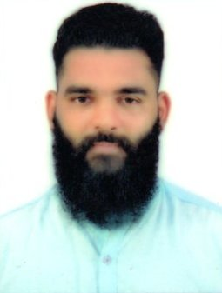

**ABDUL RAHIMAN NOUSHAD**

E-mail: [abdulrahimannoushad07@gmail.com](mailto:abdulrahimannoushad07@gmail.com)

WhatsApp: +91 8123190313

**OBJECTIVE:-**

Seeking a challenging and growth-oriented profession with committed & dedicated people, which will help me to explore myself fully and realize my potential, where I can utilize my educational and technical background for the benefit of the organization.

**STRENGTHS:-**

* Hardworking and problem solving.
* Good communication and interpersonal skill.
* Positive attitude.

**ACADEMIC QUALIFICATION:-**

|  |  |  |
| --- | --- | --- |
| **Course** | **Name of Institute** | **Board/University** |
| SSLC | Sayyid Madani English Medium High School, Kallapu | Karnataka Secondary Education Examination Board, Bangalore |
| DIPLOMA IN PARAMEDICAL | Colaco Paramedical College, Kankanady, Mangalore | Karnataka Paramedical Board, Bangalore, Karnataka |

**TECHNICAL QUALIFICATION:-**

* Diploma in Computer Financial Application (DCFA), Tally Erp9.

**WORK EXPERIENCE:-**

* Worked as **Accountant** in United Marine Product at Ullal Mangalore for 2 Year.

**JOB RESPONSIBILITIES:**

* Provides financial information to management by researching and analyzing accounting data; preparing reports.
* Documents financial transactions by entering account information.
* Recommends financial actions by analyzing accounting options.
* Summarizes current financial status by collecting information; preparing balance sheet, profit and loss statement, and other reports.
* Substantiates financial transactions by auditing documents.
* Prepares special financial reports by collecting, analyzing, and summarizing account information and trends.
* Maintains customer confidence and protects operations by keeping financial information confidential.
* Worked as **Sales Representative** in Marketing& Billing at Ullal Mangalore for 1 Year.

**JOB RESPONSIBILITIES:**

* Serves customers by selling products and meeting customer needs.
* Adjusts content of sales presentations by studying the type of sales outlet or trade factor.
* Focuses sales efforts by studying existing and potential volume of dealers.
* Submits orders by referring to price lists and product literature.
* Provides historical records by maintaining records on area and customer sales.
* Contributes to team effort by accomplishing related results as needed.

**PERSONAL PROFILE:-**

Father Name : Mohammad Husain

Date of Birth : 02-01-1997

Nationality : Indian

Civil Status : Single

Languages Known : English, Hindi, Kannada and Malayalam

Permanent Address : 16-605, 2nd UT Compound, Mukkachery,

Ullal, Mangalore Taluk, D.K District,

Karnataka, India – 575020

**DECLARATION:-**

I hereby declared that the above mentioned information is correct up to my knowledge and I bear the responsibility for correctness of above mentioned particulars.

Place: Mangalore (Abdul Rahiman Noushad)