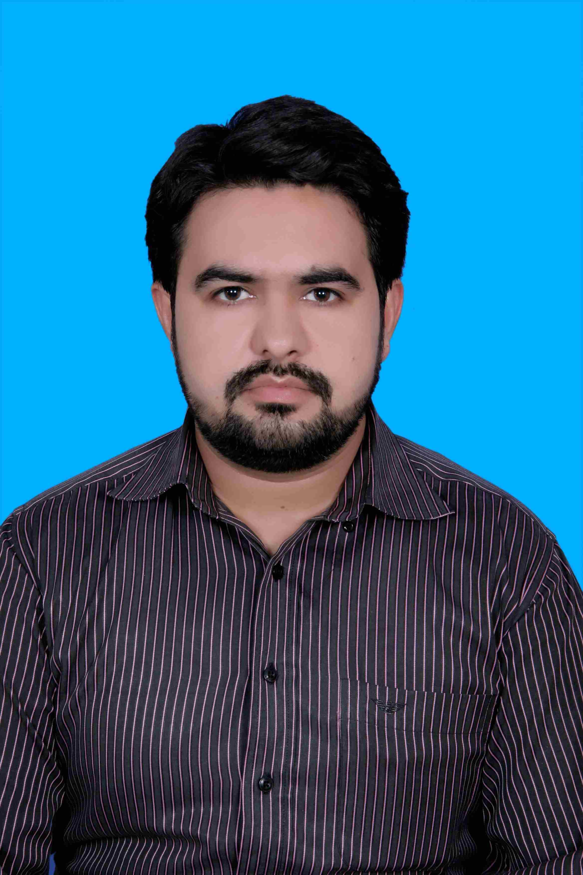
sohail ghani
Saif Ali Hamrani street 156
Al Ajman,UAE

volvine@hotmail.com
009710561853386

Eligibility
Pakistani Citizen
Good in English / Urdu / Punjabi/ Pashto

Objective | Initially, to learn everything there is about my field, theoretically as well as practically and in the end to invent something that will help this mankind.
Education | Degree Name SESSION Aggregate  MBA  (Marketing) 2009-2011 (3.13/4)76% | Institute  University of central Punjab Lahore
Education | BBA(Hons)  (Marketing) 2004-2008 (2.62/4) 71% | University of central Punjab Lahore
Education | F.Sc.  (Pre-Eng.) 2002-2004 (625/1100) 57% | Khanewal public school  & college
Education | Matriculation  (Science) 2000-2002 (648/850) 76% | Government Model High School, Khanewal
Work Experience | Worked in NEEDLE CRAFT FOR CLOTHING INDUSTRY as a  “Store In charge”  01 year 4 months (Starts from 01 Oct 2015 to 31 Jan 2017) AZ’ZARQA, JORDAN  - Maintain all Fabric Stocks of three stores (FINE, CAUSAL and NCL) on ERP inventory system.  - Making Inward Gate Pass (IGP) and Goods Receipt Note (GRN) on ERP inventory system.  - Arrange the stock warehouse in proper order for audit convenience.  - Issue Fabric to the cutting department after posting on ERP inventory system.  - Maintain complete records of each receiving, issuance and balance.  - Making STN (Store Transfer Note).  - Handling the daily bases issues reports and forward to high management.  - Receive goods and ensure their GRN in ERP Inventory.  - Reports directly to Manager Inventory & Store in all material and store concerning matters.   Worked in UBL BANK as a Cash Officer  4 months (Starts from 16 May 2015 to 16 Aug 2015)  - Handling of Wheat payment handling  - Target orientation, meeting monthly targets as defined by supervisor.  - Making customer visits on daily basis as per frequency defined by the supervisor.  - Maintaining a record of all telephone calls, visits to customers in form of a call report to be submitted to the supervisor on daily basis.  - Maintaining a data base on excel for all customers introduced to the bank with updated contact details and sharing this on weekly basis with the supervisor.  - Secure and refer intelligent feedback from the customers to the Sales Head and product management team for product improvement.  - Extracting maximum potential from an existing customer.  Worked in Mobilink Khanewal (7125)  As a Customer Care Representative & Supervisor  2 years 3 months(Starts Oct 01,2012 to Dec 31,2014)  - Actively work towards the achievement of daily quantitative targets.  - Monitoring the team performance.  - Resolve product or service problems by clarifying the customer's complaint.  - Determining the cause of the problem; selecting and explaining the best solution to solve the problem; expediting correction or adjustment; following up to ensure resolution.  - Helping DO’s to achieve their targets.
Internship  Work |  Worked in DCO(FINANCE & PLANNING) Khanewal  As a NIP(Internee)  4 months (Starts 29 march 2011 to 31 July 2011 )
Volunteer ship work | Done 25 days worked in “PAHCAHAAN” protect children’s from abuse.
Technical  Skills | - MS Office  - Windows XP, Vista, Keen user of Internet.
Areas of Interest | - Administration  - Marketing  - Sales  - Ware Housing
Honors & certificates | - Basic Customer Care Franchise Training(BCCFT)  - 3 months MS Office certificate (Word, Power point, Execl, Window installation)  - Got scholarship in MBA
Strengths | - Good verbal and written communication skills  - Ability to work alone or as part of a team  - Ability to work in high pressure environment.
Personal  Details | Father’s Name Abdul Ghani  Date of Birth 08-07-1986  NIC No. 36103-1738800-9  Nationality Pakistani  Domicile Khanewal  Marital Status Married  Passport No. YH4108003

