RESUME

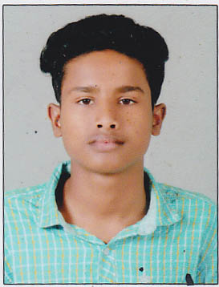
VISAKH.C
Chinnamkottil House
Katampazhipuram (Po)
Palakkad (Dt)
Kerala, Pin- 678633
Mobile: 9207267990
Email Id: visakhviswanathan016@gmail.com

OBJECTIVE

To work with an Organization where my skills are used to the fullest extent and have an opportunity to grow with the Organization.

EDUCATIONAL QUALIFICATIONS

Course | Board/  University | Year of passing | Percentage
SSLC | Board of Public Examinations, Kerala | 2016 | 61%

TECHNICAL QUALIFICATION

- Skill India-DDU- GKY-Quess Corp Ltd (ITES-TECHNICAL SUPPORT EXECUTIVE)

PERSONAL STRENGTH

- Friendly, Optimistic, Self Confident, Hard working.

WORK EXPERIENCE

- Worked as a Cashier in D-Mart, Hennur, Bangalore for 2 years.

COMPUTER SKILLS

- MS Office

LANGUAGES KNOWN

Languages | Speak | Read | Write
Malayalam
English
Tamil
Hindi
Kannada

PERSONAL PROFILE

Name : Visakh.C
Father’s Name : Viswanathan.C
Sex : Male
Date of Birth : 14-04-2001
Marital Status : Single
Nationality : Indian
Religion : Hindu

DECLARATION

I hereby declare that the above mentioned information are true and correct to the best of my knowledge and belief.

Place: Palakkad VISAKH.C

Date:

