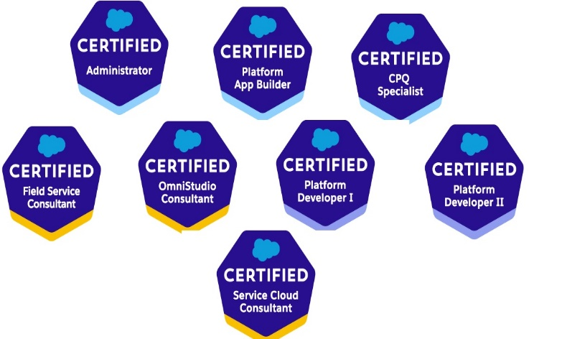

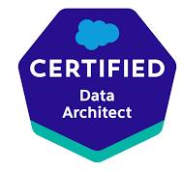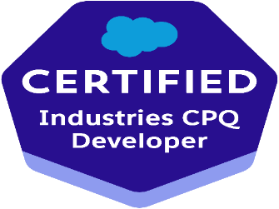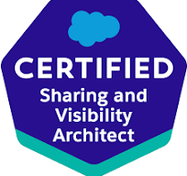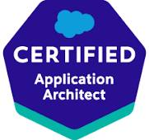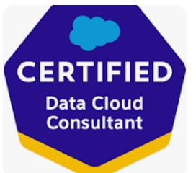

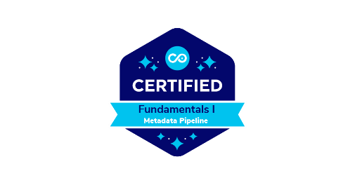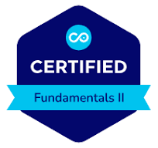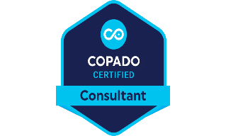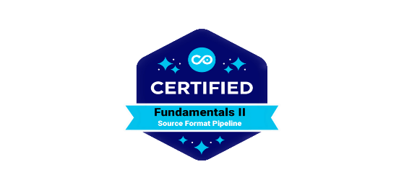

**Certifications:**

1. Salesforce Administrator
2. Salesforce Platform Developer1
3. Salesforce Platform DeveloperII
4. Salesforce Service cloud Consultant
5. Salesforce Field Service Lightning Consultant
6. Salesforce CPQ Specialist
7. Salesforce Platform App Builder
8. Salesforce Omni Studio Consultant
9. Salesforce Industries CPQ Developer
10. Salesforce Data Architect
11. Salesforce Sharing and Visibility Architect
12. Salesforce Application Architect
13. Salesforce Data Cloud Consultant
14. Salesforce AI Associate

Kondapalli Srinivasa Varaprasad  
*Email*: Varasree67@gmail.com  
*Phone*: +91 8978354943

https://www.linkedin.com/in/srinivasa-varaprasad-k-b6765078/

**Salesforce Technical Architect /Salesforce Practice Head**

Exclusive Specialization:

* + Salesforce SalesCloud
  + Salesforce ServiceCloud
* Salesforce Revenue Cloud (CPQ & Billing)
* Salesforce Commerce Cloud
* Salesforce Finance Service Cloud
* Salesforce Field Service Lightning Cloud
* Salesforce Vlocity (Omni Studio)
* Industries CPQ

Total IT Experience: 20+ years  
Relevant Experience:

Salesforce Sales Cloud--------------------------17 years

Salesforce Service Cloud------------------------10years

* Salesforce Development: 16 years
* Vlocity (Omni Studio, Industries CPQ): 4 years
* Salesforce Revenue Cloud: 6 years
* Technical Architect/Head: 12 years
* Salesforce Commerce Cloud: 6 years
* Salesforce CPQ: 8.6 years
* Field Service Lightning: 5 years
* Finance Service Cloud: 5 years

Roles and Responsibilities:

* Solution Design: Collaborate with stakeholders to translate business requirements into scalable Salesforce solutions.
* Architecture Planning: Develop high-level architectural designs aligned with best practices.
* Salesforce Platform Expertise: Extensive knowledge of Salesforce clouds, customization, integrations, and security.
* Technical Leadership: Guide development teams in design patterns, coding standards, and best practices.
* Integration and Data Management: Design and manage integrations between Salesforce and other systems.
* Governance and Compliance: Establish models for data security and regulatory compliance.
* Performance Optimization: Address performance bottlenecks by optimizing configurations.
* Platform Upgrades and Migrations: Plan and execute platform upgrades and data migrations.
* Security and Access Control: Implement robust security measures.
* Documentation: Prepare technical documentation, architecture diagrams, and user guides.
* Client Communication: Present technical solutions and gather feedback.
* Continuous Learning: Stay updated on Salesforce product updates and trends.
* Problem Solving: Analyze and propose solutions for complex challenges.
* Code Reviews: Ensure code quality through reviews.
* Quality Assurance: Collaborate with QA teams to validate functionality.
* Training and Mentoring: Train and mentor team members.
* Revenue Growth & Profitability – Driving revenue through new business opportunities, client engagements, and strategic partnerships while optimizing costs to maintain profitability.
* Budgeting & Cost Management – Managing practice budgets, resource allocation, and operational efficiency to ensure financial health, including forecasting, margin improvement, and cost control.
* Strategic Leadership & Growth – Defining the vision, roadmap, and strategy for the Salesforce practice, driving business growth, revenue, and market positioning through solution offerings, partnerships, and innovation.
* Delivery Excellence & Team Management – Ensuring high-quality project delivery, aligning solutions with client needs, managing teams of architects, consultants, and developers, and fostering capability development within the practice.

Area of Expertise:

* Deep understanding of Software Development Life Cycle (SDLC)
* SFDC Administrative tasks (e.g., User Roles, Workflows, Validation rules)
* Proficiency in Apex Classes, Apex Triggers, Visual Force Pages, SOQL, and SOSL
* Data Migration using tools like Import Wizard, Workbench, and Apex Data Loader
* Experience in Salesforce Integration (SOAP API, REST API, Web Services)
* Expertise in Lightning Components Framework and Security Model

Education:

* MTech - JNTU, Hyderabad (2013)
* MBA (Business Analytics) - Hyderabad Central University (2022)
* B. Tech - JNTU, Hyderabad (1990)

Professional Experience:

**E3 Global Inc., USA Salesforce Practice Head/Salesforce Technical Architect  
*Aug 2015 - Present***

Project 1: Industries CPQ (Communications Cloud, Manufacturing Cloud, Energy and Utilities)  
*Client: Viasat, Inmarsat | Oct 23 ongoing,Vlocity and CPQ aviation projects*

* Technologies: Vlocity, Omni Studio, Salesforce CPQ
* Responsibilities:
  + EPC Product Design, Order Management, Price Lists
  + Business Rules Engine, Omni Scripts, Flex Cards
  + Contract Lifecycle Management, Document Generation
  + Integration with various external systems

Project 2: Omni Studio (Vlocity) Project  
*Client: Frontier Communications | Nov 2020 - Sep 2023*

* Technologies: Salesforce CPQ, Vlocity, Omni Studio
* Responsibilities:
  + Enterprise Product Catalogue, Business Rules Engine
  + Data Raptor REST API, Omni Scripts
  + Integration with Apex for seamless data flow
  + Contract Lifecycle Management and Approval Process

Project 3: Complex Credit Project  
*Client: ABSA | March 2021 - May 2023*

* Technologies: Salesforce Financial Service Cloud
* Responsibilities:
  + Developing Calculators for financial operations
  + Managing Origination, Sanctioning, and Fulfillment processes
  + Supporting business operations with Salesforce solutions

Project 4: B2B Commerce Lightning Setup  
*Client: Dragon Mart, Dubai | July 2020 - June 2022*

* Technologies: Salesforce B2B Commerce, Lightning
* Responsibilities:
  + Stores Creation and Configuration
  + Price Calculations, Inventory, Taxation Management
  + Order Management, Delivery Management
  + Customer Support, Feedback Management, Analytics
* Project 4B: Marketing Cloud
* Email Marketing
* Customer Journey Mapping
* Mobile Marketing
* Analytics and Reporting
* Integration with Salesforce CRM

Project 5: Salesforce CPQ & Billing  
*Client: Neustar USA and DHS Trimble | 2015 - 2020*

* Technologies: Salesforce CPQ, Billing
* Responsibilities:
  + Product Configuration, Price Books, Price Rules
  + Quote Management, Contract Management
  + Invoice & Order Management, Payments, Debit/Credit Notes
  + Integration with external billing and payment gateways
* Project 5B: Marketing Cloud | 2018 -2020
* Email Marketing
* Customer Journey Mapping
* Mobile Marketing
* Analytics and Reporting
* Integration with Salesforce CRM

Project 6: App Exchange Products  
*Client: CEPTES*

* Products: Real Estate 360, DataArchiva
* Responsibilities:
  + Automate operations for real estate management
  + Salesforce data archiving solutions for cost optimization
  + Enhancing compliance and governance within Salesforce

Project 7: Field Service Lightning Integration  
*Client: DMS US, ESO Solutions, Zing Box USA, Illumio USA | 2010 - 2015*

* Technologies: Salesforce Field Service Lightning, .NET
* Responsibilities:
  + Booking appointments from Web UI, Service resource assignments
  + Complete dispatch process integration with Salesforce

Project 8: Citycom Unified Management of Telecom Networks  
*Client: Citycom UK*

* Technologies: Salesforce Sales Cloud, Service Cloud, Community Cloud
* Responsibilities:
  + Creating architecture and implementation plans
  + Overseeing technology solutions and post-execution reviews
  + **Migrating from Salesforce Service Cloud to Salesforce Platform:**
  + 1. Understand the Business Need
  + 2. Analyze the Current Service Cloud Setup
  + Review data models: Objects, fields, relationships, and data volumes.
  + Assess configurations: Flows, Process Builders, Validation Rules, and Custom Code (Apex/Triggers).
  + Document integrations: External systems connected to Service Cloud.
  + Examine reports and dashboards in use.
  + Evaluate any existing automations or third-party applications.
  + 3. Plan the Target Salesforce Platform Setup
  + Design the data architecture for the Platform.
  + Decide which components (e.g., standard vs. custom objects) to retain or replace.
  + Plan for custom development where necessary (e.g., building custom apps or utilities).
  + Ensure compliance with security, sharing settings, and user roles on the Platform.
  + 4. Prepare for Migration
  + 5. Develop and Configure the Target Platform
  + 6. Migrate Data
  + 7. Test the Migration

Project 9: Fleet Management Dashboard  
*Client: Tesla Motors, US*

* Technologies: Salesforce, SQL Database
* Responsibilities:
  + Lead end-to-end implementation for fleet management
  + Integration with SQL database for incremental syncs

Previous Experience:

Jeevan Technologies Pvt Ltd., Chennai, India  
*May 2014 - July 2015*  
Salesforce Solutions Architect/Technical Architect

* Project 1: Case Management Setup (Service Cloud)  
  *Client: Deloitte US | May 2014 - Aug 2014*
  + Led a team in the full implementation of case management features
* Project 2: Salesforce Lead Consultant  
  *Client: Daikin AC Industries, Thailand | Feb 2014 - Apr 2014*
  + Worked on-site as a Salesforce Lead Consultant

Deepala Technologies Pvt Ltd., Hyderabad, India  
*Apr 2010 - Feb 2014*  
Salesforce Team Lead/Technical Architect

Skill Cap Global ITS Solutions, Hyderabad, India  
*March 2008 - March 2010*  
Salesforce Developer

Genuine Technologies Pvt. Ltd., Hyderabad, India  
*August 2003 - March 2008*  
Software Engineer