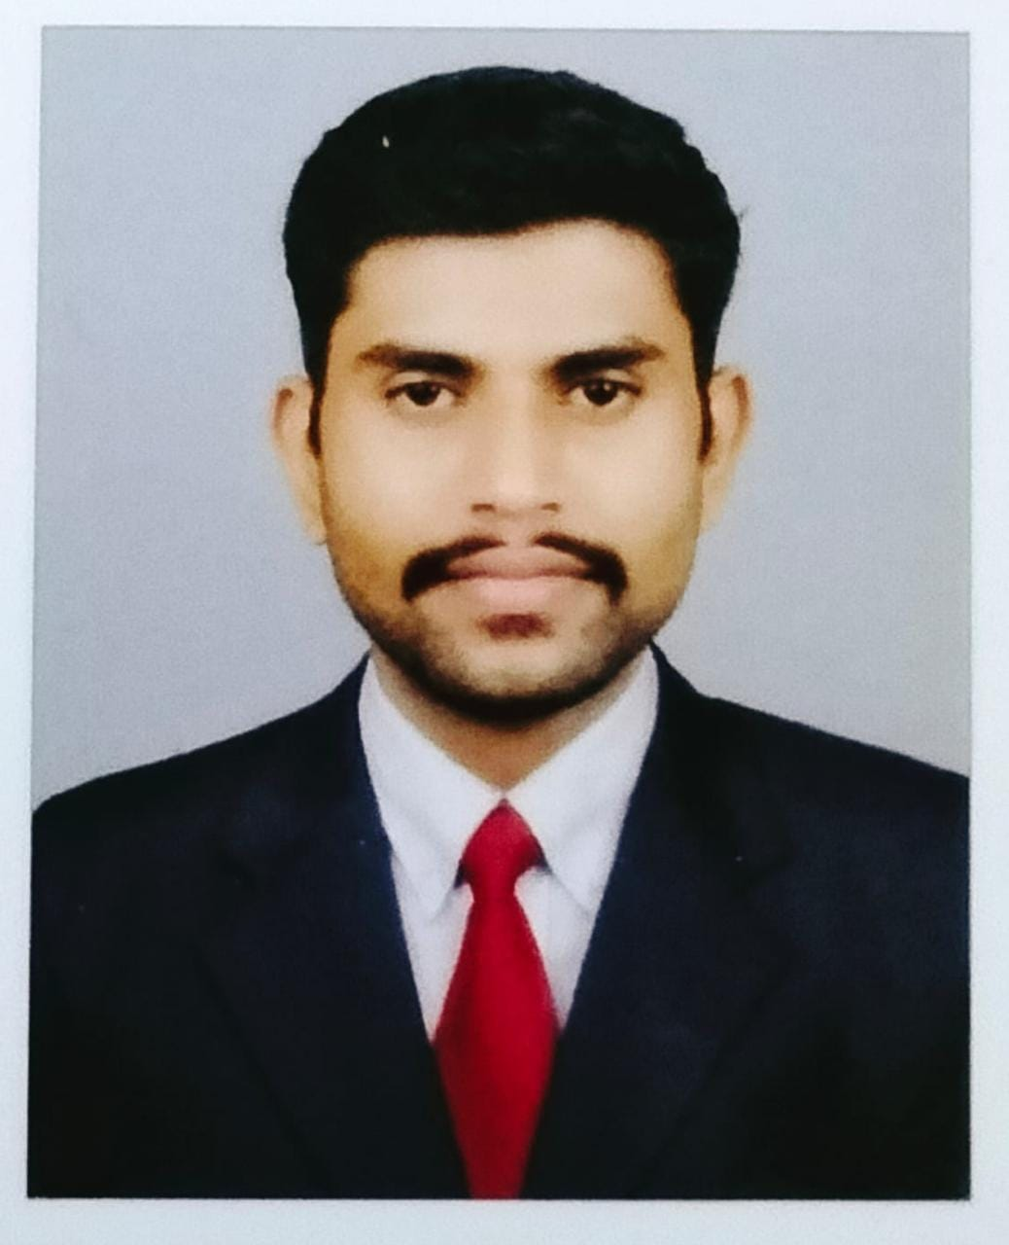

Jobin Jose CURRICULUM VITAE

O B J E C T I V E

To work in a challenging environment where I can make use of my talents and prove my abilities for the growth of the Company, and to enhance my career by way of working in a vibrant company, which paves the way for the same. Seeks for a challenging position as an Accounts Executive at a growth-oriented firm, which will allow me to both further utilize my skills and acquire new abilities.

S U M M A R Y O F E X P E R I E N C E

I have total 2 years of diversified experience in India, which are as follows:

- Excellent communication and comprehension skills. Excellent skills in Accounts and Administration.
- Expert level knowledge of MS-office applications and Tally

(i) Designation : Administration & Accounts
Period : From May 2020 to 15th December 2021.
Name of Employer : Akshaya Centure Pothukallu, Malappuram, Kerala

Akshaya Centers have been emerged as a finest network of effective Common Service Centers (CSC) envisioned to deliver a multitude of G2C, G2B as well as B2C services to the public under a single roof. Presently, around 2,650 Akshaya e-centers spread across Kerala with at least 2 centers in each Panchayats.
Reporting to Manager and I was responsible for:
- Monitoring Day to day activities.
- Keep track the bank ledger
- Keep updating all other General Ledger
- Bank reconciliation & ledger analysis
- Informing the application updated to clients.
- Monthly Salary distribution to staff

(ii) Designation : Loan Officer and Accounts
Period : From May 2019 to April 2021
Name of Employer : IMPACT (Innovative Microfinance for Poverty Alleviation and
Community transformation) Kerala
Reporting to General Manager and I was responsible for:
- Monitoring Day to day activities
- Keep track the bank & general ledger
- Bank reconciliation & ledger analysis
- Monitoring loan process
- Disbursement of personal loan
- Collection of personal loan installment
- Closing of personal loan
- Monthly Salary distribution to staff

E D U C A T I O N A L Q U A L I F I C A T I O N ( S )

- Bachelor Degree (B.com Finance)
- Year: 2019
AMAL COLLEGE OF ADVANCED STUDIES, NILAMBUR
(Affiliated to Calicut University in Kerala)

- Diploma in Computer Application & Tally
Year: 2019

P E R S O N A L P R O F I L E

Date of Birth : 24-09-1998
Sex : Male
Languages Known : (i) English
(ii) Malayalam

Nationality : Indian
Marital Status : Unmarried
Visa Status : Visit Visa
Contact No : 0505054866

