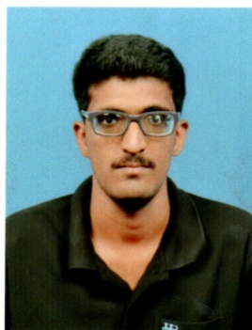
A.ABUL MUSAFFAR
: + 91 9750885361
: abularif1997@gmail.com

Objective

To be a part of a professionally managed company with scope for a challenging career, opportunity for learning, excellent and continuous improvement coupled with growth and individual development, to broaden my perspective and my skills. Willing to work as a key player in challenging & creative environment.

Educational Qualification

NAME OF THE QUALIFICATION | NAME OF THE BOARD AND UNIVERSITY | YEAR OF PASSING | PERCENTAGE OF MARKS
M.com | JAMAL MOHAMED COLLEGE (AUTONOMOUS), TRICHY | 2019 | 60%
B.com | JAMAL MOHAMED COLLEGE (AUTONOMOUS), TRICHY | 2017 | 62%
HSC | S.V.N MATRIC HR.SEC.SCHOOL ERODE | 2014 | 69%
SSLC | BRILLIANT MATRIC SCHOOL  MUTHUPET | 2012 | 59%

Technical Skills
- TALLY VERSION 9.0
- MS OFFICE
- FINACLE

Working Experience:

1. LAKSHMI NISSAN. AMBATTUR. CHENNAI
- Accounts executive – 03 April 19 to Till Date.

Main Responsibility:
- Petty cash tally
- Report preparation for audit
- Billing in tally
- Payable, Receivable
- Reconciliation
- File Keeping

2. KNMA Associates. Trichy.
- Auditor Assistant – 01DEC 17 – 31 DEC18.

Main Responsibility:
- Concurrent auditor at uco bank
- Yearly audit at Repco bank-karur
- Stock audit in Volkswagen Finance, ITC,Dr.Reddy’s laboratories-Trichy

Achievements:
- I finished tally 9.0 in Jamal Mohamed college (well trained)
- I trained communication class in SADCE centre
- I participated in Inter- national seminar at Jamal Mohamed college
- I participatedin National seminar at Jamal Mohamed college

Personal skills & Abilities:
- Self-Confident.
- Quick Learner.
- Smart Working.
- Punctual.
- Good Communication Skills.
- Adaptability.
- Ability to work with people as a team and also individually.

STRENGTHS
- Self-Initiative with ‘can do’ Attitude
- Ability to Solve Problems Effectively
- Good Communication and Interpersonal skills
- Willingness to learn, explore, and upgrade knowledge
- Positive work attitude
- Team Player

Personal Data

Permanent Address: 21/27, PETTAI ROAD

MUTHUPET, THIRUTHURAIPOONDI (TK)

TIRUVARUR (DT) – 614 714.

Date of Birth: 24 SEPTEMBER 1997

Marital Status: Single

Languages Known: English and Tamil

Age & D.O.B: 23 years

Sex: Male

Nationality: Indian

