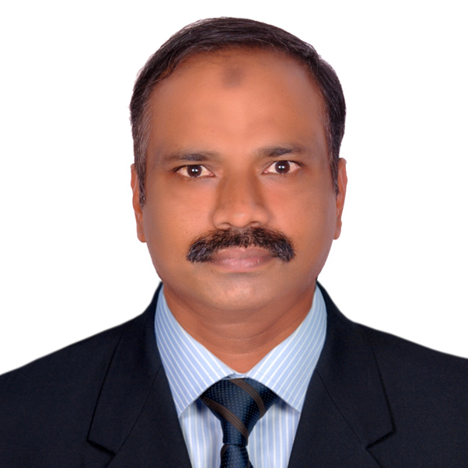

**ENGR: ANWAR BASHEER**

**Email:anwarshebu@yahoo.com**

**Mob No : 00971508211525**

**OBJECTIVE**

A proven proactive Engineer having Diploma in Civil Engineering holder UAE Driving License and of 15years experience in Middle East.

Presently looking for a career move that is both challenging and rewarding with scope for growth and career development in a multinational environment, where I can use my present experience and academic knowledge to grow within the organization, and to improve my future credentials.

**PERSONAL SKILL**

* Good team leader, communication and negotiation skills
* Hard working and sincere to duties & entrusted responsibilities
* 15 Years’ Experience in Middle East
* I can lead and willing to be lead. I believe in teamwork or individual work

**EDUCATIONAL QUALIFICATION**

* Diploma in Civil Engineering from the Board of Technical Education Kerala, India in 1992

**COMPUTER KNOWLDGE**

* AUTO CAD
* M.S OFFICE

**WORK EXPERIENCE**

* 15years in Middle East
* 10 years in India.

1. **1.Organization**  : DEWAN ARCHITECTS AND ENGINEERS

FROM 2015 TILL

Designation : Civil Inspector / Architect Inspector

**PROJECT : FOUNTAIN VIEWS (G+70)**

**2. Organization** : **AL OTAIBA GROUP, ABUDHABI- U.A.E**

June 2011 to May 2014

Project : ADNOC

Designation : QC ENGINEER

**Responsibilities**:

* Periodic inspection of overall construction site activities with ADNOC Representatives
* Prepare M.V.R & I.T.R.
* Submittal and follow up for approvals
* Checking and preparing site reports design and drawings
* Ensuring site safety
* Prepare daily, weekly and monthly reports submit to the Project manager
* Lasing with client and their representatives including attending regular meeting to keep them informed progress
* Verify all invoices and variations claims from Consultant/Contractor/ Sub Contractor /

Suppliers

Prepare method statement and risk assessment

**3. Organization** : **MOZOON** **ENGINEERTING CONSULTANCY**

Fujairah - UA.E, December 2009 to March 2011

Projects : Commercial and Residential building Villas and High rise

Building

Designation : Consultant Engineer

* Carryout feasibility study for project design cost duration and submit to clients approvals
* Periodic inspection of overall construction site activities and giving instruction to
* Submit site inspection documents to municipality for checking structural parts
* Contractor engineer for the progress and quality of work
* Carried works as per drawing and specification
* Maintain daily report of progress Submittal and follow up for approvals
* Co-ordinate with client and local authorities for approvals
* Submit reports daily, weekly and monthly for the client meeting
* Monitor quality Programme
* Budget and time constraints
* Monitor site safety policies
* Keep good manners with client as well as Municipality Engineers

**4. Organization** : **AL ZAWRA CONT.CO, SHARJAH – U.AE**

1998 to 2001

Designation : Site Engineer

Projects : Villas and Commercial Buildings

**5. Organization** : **SUPREM CONTRACTING CO.,** Kerala, India

1992 to 1997

Project : Commercial & Residential building

Designation : Site Engineer

**MAJOR PROJECTS INVOLVED**

**G+70 fountain views (EMMAR)**

* G+30 Building, Al Hayel Investment, Fujairah
* Al-Rostamani Twin Tower project, Fujairah

**PERSONEL PROFILE**

Permanent Address : Madathil Valappil House

Trithala.P.O., Palakkad Dist.

Kerala- India

Name of Father : Ebarahin Kutty.

Nationality : Indian

Religion : Muslim

Date of birth : 25.04.1971

Languages Known : English, Arabic, and Hindi Malayalam

**Driving License NO U.A.E # 120139**

Validity : 12/10/2024

Passport No : T 3278674

Validity : 03/02/2030

References : Available Upon Request

|  |  |
| --- | --- |
| Declaration | I confirm that the information given in this CV and all appendices is true, complete and accurate and no information requested or other material information has been omitted. |