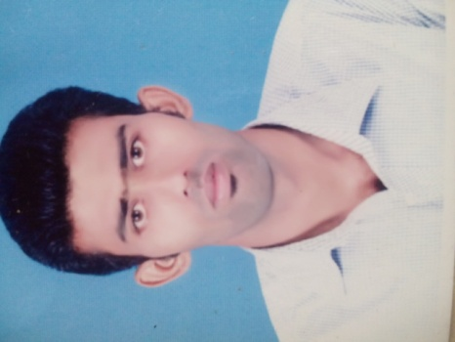

**MD SADDAM HUSSAIN**

**Dubai, U.A.E**

**Mobil No: +971527878071**

**E-mail:** [sanaf3570@Gmail.com](mailto:sanaf3570@Gmail.com)

**aPPLICATION FOR THE POST OF: ac technician**

**objective**

My Objective behind applying for a job to obtain a suitable position in a professionally corporate environment An organization where in an employer relationship is based on mutual respect & recognition of professional.

**Personal Details**

Name : Md Saddam Hussain

Father’s Name : shahabuddin

Date of Birth : 24/02/1993

Nationality : Indian

Gender : Male

Marital Status : Married

Address : Police colony sec-A , Anishabad, Patna (Bihar)

Language Known : English, Hindi,Urdu

Visa Status : Employment Visa

**EDUCATIONAL QUALIFICATION**

* Matric from B.S.E.B, Patna in 2009 with 2nd Div.
* I.Sc from B.I.E.B, Patna in 2011 with 2nd Div.
* B.A (His. Hons) from Magadh University in 2015

**technical QUALIFICATION**

* ITI (Electrician) from NCVT in 2013 with 1st Div

**computer skills**

* Diploma In Computer Application (DCA)
* Desktop In Publishing (DTP)

**work experience-**

* 3 Years experience as a Electrical incharge in Patliputra Sports Complex, Patna
* work in Star Sport Pro-Kabaddi Session -2 in Patna Project as a Electrical Incharge
* Working at a time Ac Technician from Shapoorji Pallomji llc Dubai U.A.E Till Date

**key skills**

* Hard Working , Punctual & Optimistic
* Good Learning & Listening Abilities
* Committed to providing excellent quality service.
* Willing to go out of my way to make guests comfortable.

**passport details**

* Passport No : N 8621541
* Date of Issue : 07/03/2016
* Date of Expiry : 06/03/2026
* Place of Issue : PATNA BIHAR

**Reference**

References can be provided if required

**declaration**

* I certify that all the details provided above are all correct according to my knowledge and belief.

**SADDAM HUSSAIN**

DATE-