Resume

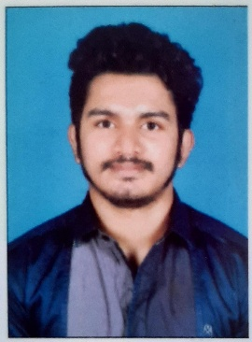
Richard Brice
Mail id: bricerichard115@gmail.com
Visa status: visiting visa
Passport number: U4573430
Current location: Sharjah
Mobile number: 0565872731

CAREER OBJECTIVE

To work for a progressive organization in a highly motivating and challenging environment that provides the best opportunities to grow and utilize my potential to the fullest to achieve the organization’s goal while achieving my personal goals.

EDUCATIONAL PROFILE

COURSE | YEAR | Institution/ University
B.com( Taxation) | 2017-2020 | M.G University
Higher secondary | 2015-2017 | Church View College Ponkunnam
SSLC | 2014-2015 | JJ Murphy Memorial School Yendayar

PERSONALITY TRAITS

- Good Communication skills & Positive Thinking.
- Sincere hard work & motivation.
- Confident & optimistic in arriving at a solution.
- Eagerness to learn new things

TECHNICAL SKILLS

- Good knowledge in Microsoft Word, Excel, Power Point
- Good knowledge in Tally
- Time management
- Team player
- Having fast learning skills for any technology

STRENGTHS

- Determinant to work
- Self-confidence
- Goal oriented
- Flexibility

PERSONAL profiles

Name : Richard Brice
Gender : Male
Fathers Name : Brice V Mangalam
Date of Birth : 28-07-1999
Marital Status : Single
Nationality : Indian
Hobbies : Motorcycling, Travelling, Music, Football
Permanent address : flat no 306,Noushad cafeteria building
Near Al Zahra hospital, Sharjah
Phone no : 0565872731
Language known :English,Malayalam,Hindi
DECLARATION

I hereby declare that the above information is correct to the best of my knowledge and belief.

:(Richard Brice)

