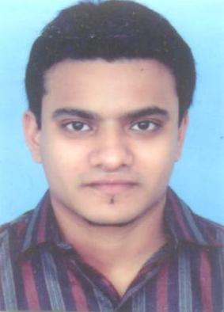

**Fawad Hussain  
Contact: +92313-2271003  
Email:** [**fawadhussain12@gmail.com**](mailto:fawadhussain12@gmail.com)

**CAREEROBJECTIVE:**

To obtain a position in reputed organization that will enable me to use my strong organizational skills, quality assurance, education and add demanded value to the organization I work for and thus to prove my worth.

**PROFESSIONAL WORK EXPERIENCE:**

**Organization:** **Hamdard University**

**Tenure:**  **April 2017 – Till Present**

**Designations:** **Assistant Examination Officer**

**Responsibilities:**

* Liaising with the staff to organize examinations
* Making announcements to the student at the start and end of the examinations
* Responsible to Prepare Examination Schedules, Room Plans and seating arrangements
* Dealing with students and faculty members of their issues
* Coordinating with other departments of different issues
* Responsible for the storage, collection & dispatching of examination papers in a timely manner
* Handing out and collecting examination papers and answer books
* Keeping track of time

**Organization:** **Hamdard University**

**Tenure:**  **April 2014 – April 2017**

**Designations:** **QMD Officer (Quality Management Department)**

**Responsibilities:**

* Responsible for promoting public confidence that the quality & standards of the award of degrees are enhanced and safeguarded,
* Responsible for the review of quality standards & the quality of teaching and learning in each subject area,
* Responsible to ensure that the university’s assurance procedures are to fit in with the arrangements in place nationally for maintaining and improving the quality of Higher Education
* Responsible for annual monitoring and evaluation including program monitoring, faculty monitoring & students perception,
* Responsible for Departmental review, Student review, Student feedback



**Organization: Faysal Bank Ltd**

**Tenure: Dec 2011 to Feb 2014**

**Designations: Return Mail Unit Officer / MIS Coordinator**

**Responsibilities:**

* Confirmation calls to customer to confirm return reasons of cards.
* Call customers on returned credit cards, Debit cards, BTF statements, credit card

Statements and verify the information and provide further assistance.

* Check the details of Customers on VISION+/ RMS
* Address change on online system RQMS.
* To develop & maintain the MIS Reports.
* To assign weekly files to officers.
* Resolve customer complaints on Siebel & RMS.

**ACADEMIC EDUCATION:**

**EXAMINING BODY: YEAR**

* Graduation University Of Karachi 2007
* Intermediate Board of Intermediate Education, Karachi 2002
* Matriculation Board of Secondary Education, Karachi 1998

**COMMUNICATION AND INTERPERSONAL SKILLS:**

* Outstanding command over verbal and non-verbal communicative & interpersonal

Skills.

* Strong organizational, managerial, problem solving, interpersonal and negotiation

Skills.

* Confidently able to work independently or in a team to deal effectively with educators

& employees.

* Flair to organize & prioritize tasks to meet deadlines.
* Ability to manage multiple projects with minimal supervision.
* Have a good level command over English and Urdu Languages.

**ADDITIONAL SKILLS:**

* **MS Office**  (All versions, MS Word, MS Power Point and MS Excel)
* **MS Excel** (MS Formulae, Reports Automation, Macros, Presentations,

Analysis)

* **Banking Software** (Seibel, Symbol, Vision Plus, TCSS & RQMS)

**INTERESTS AND HOBBIES**

* Hobbies include anything to do in Sports: Cricket, Hockey & Football are the main which I like most, Interest mainly in music, reading religious books. Enjoy and actively participate in a wide variety of sports, singing and creative activities.

**PERSONAL INFORMATION:**

**Father’s Name** : Muhammad Ilyas

**Date of Birth** : 21st Feb 1982

**Religion** : Islam

**Language**  : Urdu & English