**CURRICULUM VITAE**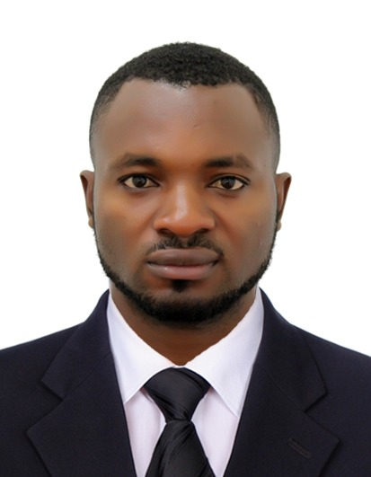

**PIHZUH EUGENE MULUH**

pihzuhe@gmail.com

Al Buhail, Dubai U.A.E.

**+971528044249**

Sales Promoter

**CAREER OBJECTIVES**

Eight years of Electronic sales promoter experience, Product Knowledge, Quality Focus, Problem Solving, Market Knowledge, Documentation Skills, Listening, Phone Skills, Resolving Conflict, Analysing Information , Multi-tasking and two years incoming and outgoing supplies and perform activities such as ordering goods, receiving deliveries, maintaining records, and reporting on daily business transactions .

**WORKING EXPERIENCE**

**Company. : Ni yang Mobile Phone Hospital Tombel Cameroon**

**Duration. : 2011 to 2015**

**Position. : sales promoter**

**Company :Miracle Electronics at Muea, Buea-Cameoon**

**Duration. : 2015 to 2019**

**Position. :Sales promoter**

* + - Lead customers throughout the entire purchasing procedure and answer questions to all inquiries
    - Demonstrate and provide information on promoted products/services
    - Create a positive image and lead consumers to use it Use lectures, films, charts, and/or slide shows
    - Distribute product samples, brochures, flyers etc. to source new sales opportunities
    - Identify interest and understand customer needs and requirements
    - Set up booths or promotional stands and stock products
    - Report on demonstration related information (interest level, questions asked, number of samples/flyers distributed etc)
    - Provide customers with information on discounts and bundle offers.
    - Assist through the payment procedures by processing cash and credit card transactions.

**CAREER COMPETENCE**

* + - IT specialist, Microsoft office, Photoshop
    - Mobile phone technician.
    - Strong ability to work, stand and move up and down for long periods without being exhausted.
    - Friendly disposition to guests, strong enthusiasm for the job; highly motivated with great ability to work harmoniously in a team.
    - Ability to keep and maintain clean appearance and treat guests politely.
    - Ability to work under pressure without being stressed.

**EDUCATIONAL PROFILE**

* + - High School Advance Level/IT
    - Bachelor Degree In Physics

**PERSONAL PROFILE**

Gender: Male

Date of Birth: 01/01/1996

Marital Status: Single

Visa Status:Tourists Visa

**LANGUAGES PROFICIENCY**

English-Excellent

**PREFERENCES**

**Mr. Bolack Blessed (Former Manager Ni yang mobile phone company-Cameroon)**

Telephone: +35796627605/ Whatsapp: +35796040293

Email: [sbolakblessed@yahoo.com](mailto:sbolakblessed@yahoo.com)

**Mr. Genarous Foleckick (Co-Worker Miracle Electronics Buea)**

Tell/Whatsapp: +237670211569