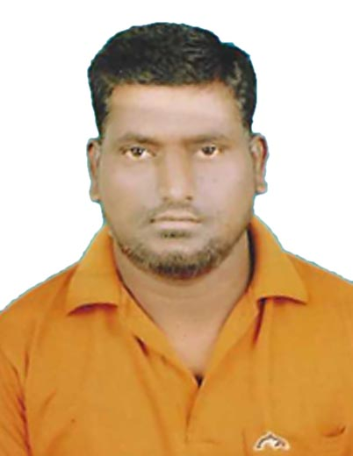
CURRICULUM VITAE

Shaik Chand

Mob: 00971 527190388

Email: jafarmomheed@gmail.com

Dubai UAE

APPLICATION FOR: CLEANER

Objective:
Intend to build a career with the leading corporate of hi – tech environment with committed and dedicate people, which will help me to explore myself fully and realize my potential. Willing to work as a key player in challenging and creative environment.

Skills:
- Able to work individually and as team.
- Hard working committed and result oriented capable of working independently.
- Accommodative attitude blended with keen sense of responsibility and leadership and willing to learn.
- Effective organization skills with planning, coordinating and leadership and controlling capabilities.
- Able to work under pressure with minimal supervision.

Work Experience:
Company: Imdaad Facility Management LLC Dubai UAE
Position: Cleaner
Location: Emirates NBD Bank , Jebal Ali Mashed
From June 2019 TO Till Date

Duties & Responsibilities:
- To come on duty with complete uniform and well groomed.
- Check / clean the designated section.
- Replace any soiled linen to fresh one.
- Complete all the amenities in the area.
- Check and report / follow up any maintenance while on duty.
- Report any lost and found in the section.
- Check / maintain / order flower for the toilets.
- Follow team leader / manager instruction related to work.

Education Qualification:
- High School

Personal Profiles:
Name : Shaik Chand
Date of Birth : 25-01-1984
Nationality : Indian
Religion : Muslim
Gender : Male
Marital Status : Married
Languages Known : English, Hindi & Telugu

Passport Details:
Passport No : M2698470
Date of Issue : 10-10-2014
Date of Expiry : 09-10-2024
Place of Issue : Hyderabad

Conclusion & Declaration:
I hereby declare that the above details furnished by me are true to the best of my knowledge and belief.

Place: Dubai Shaik Chand

