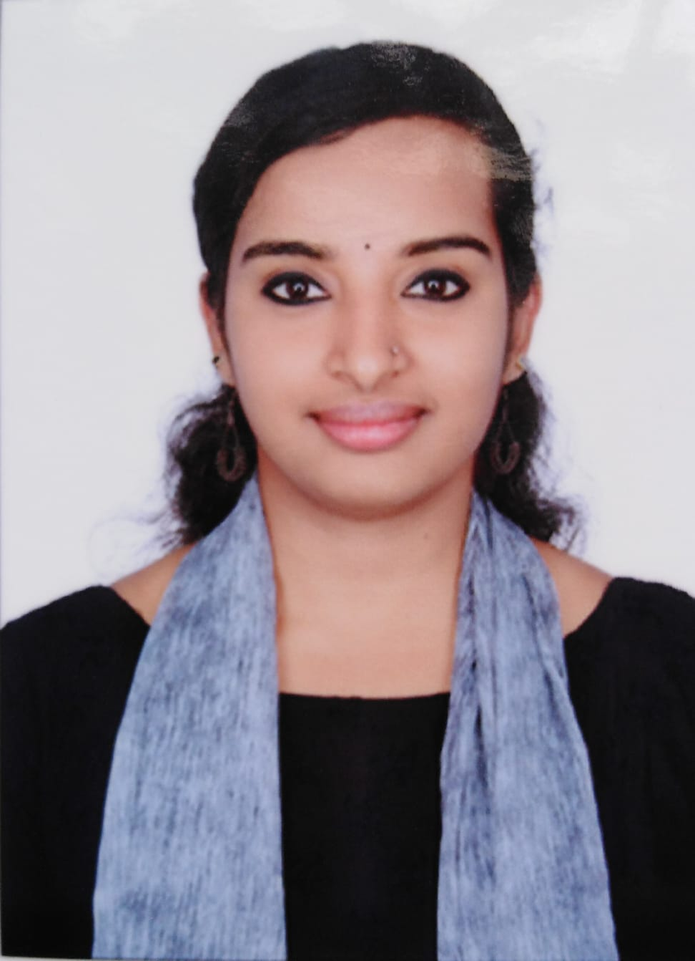 |  |  |  |  | BEULAH KURIAKOSE

CAREER OBJECTIVE

To secure a challenging position in a reputable organization to expand my learnings, knowledge, and skills. Secure a responsible career opportunity to fully utilize my training and skills, while making a significant contribution to the success of the company.

EXPERIENCE
02-04-2020 to 05-05-2021
GRO •Leela hotel -Goa

KEY ROLES

GRO
- Greeting the guest
- Check-in and check - outs
- Allotting the rooms
- Giving VIP treatment
- Handling the complaints
- Giving special care for the specially abled people.

SKILLS
- Critical thinking and problem solving
- Team work and collaboration
- Professionalism and strong work ethics
- Oral and written communication skills
- Leadership

INTERSHIP
- Industrial training at Courtyard Marriott Cochin
(10-06-2019 to 10-02-2019)
- Project on Marketing Feasibility and financial viability
(2 months)

EDUCATION
- Bachelor of Hotel management (2016-2020)-Bangalore
- Government of PUC College (2014-2016)-Bangalore
- St. Johns MHS School (2012-2013)-Tamil Nadu

PERSONAL INFORMATION

- Father name: Kuriakose George
- Mother Name: Lenny Joseph
- D.O.B: 02/10/1995
- Visa Status : Visit Visa (01/10/2021 to 25/12/2021)
- Marital Status: Unmarried
- Linguistic Abilities: English, Tamil, Malayalam, Kannada, Hindi.

BEULAH KURIAKOSE

Mullaserry house
Rock valley Housing Colony
Ambalavayal road
Sultan Bathery
Wayand-673592

 |  |  | +971503104079
 |  |  | ammubeulah7@gmail.com

