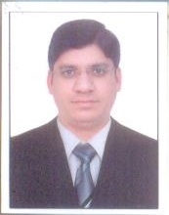
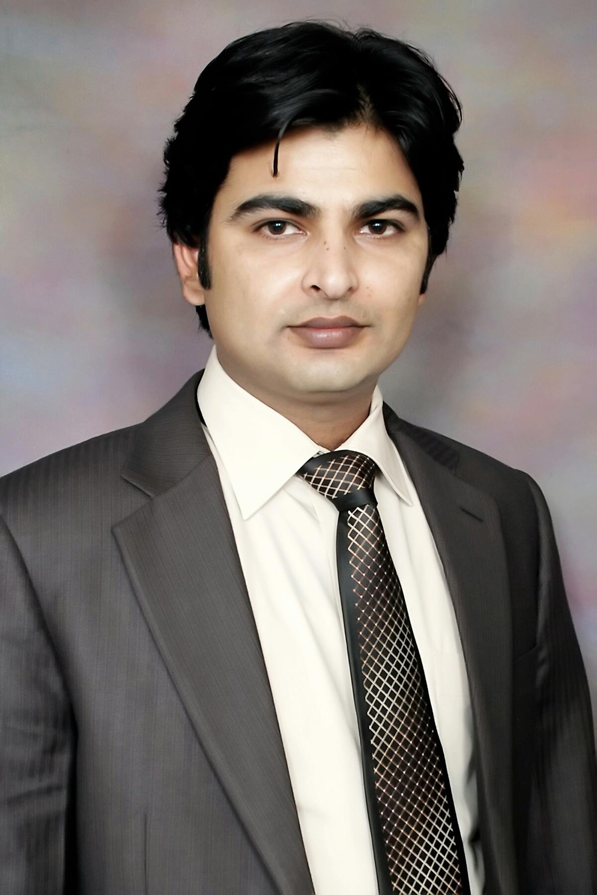
RESUME

Muhammad Faisal

Address: Electra Street, Behind Royal Rose
Hotel, Abu Dhabi, UAE.
Cell No. +971564416276
Cell No. +971569948308

Career Objective

To comply with a challenging position offering full utilization of my skills and interests in order to assert my abilities.

Career Planning

To show the best of my knowledge, policies and practices in the areas of Business Development, Sales, Marketing & Administration, and to be the best in these fields in order to achieve defined goals.

Achievements & Rewards
- Certificate of Best Trainee and Got Promoted as a Trainer in 30 Days.
- Kansai Paint 2010, Sales and Marketing Best performance award
- Certificate of Best Employee Gujranwala Region MCB 1st Quarter 2005.
- Gold Medalist, sales on regional bases Berger Paints Pakistan Certificate of Appreciation from Controller Sales.

Certifications (Professional)

- Online Social Media Marketing Course.
- Seminar “Team Building” “together everyone achieves more”
- Seminar “Selling Skills”
- Problem Solving Skills by “IMS”
- Training on Negotiable instruments.

E-mail – Muhammad.faisal198222@gmail.com
Nationality: Pakistani

I have UAE Driving License.

Professional Profile
- Active, confident and pleasant personality with academic and professional expertise having aggressive goals toward success.
- Motivated to achieve immediate and long-term goals and objectives with effective communication skills & practices.
- Effective team building with interpersonal and administrative skills for effective collaboration in organization, and relationship building with internal and external customers.
- Goal oriented approach to problem solving. Ability to work independently as well as in a team with a high motivation to complete my assigned task. Experience in communications and presentations, both oral and written to senior management. Ability to work independently as well as to plan and manage execution of others, including management of multiple teams simultaneously..

Work Experience
July-2015 to-date.

- Infinity International- TAS-HEEL (July.15 – To date)
Designation: Senior Executive Sales, Marketing and Business Development (Abu Dhabi Region)
Duties & Responsibilities:-

- Helps foreign companies and individuals in setting up their new or branch companies in Abu Dhabi.
- Providing complete consultancy and processing documents in the concerned government departments from applying to obtaining the necessary approvals to getting the final Commercial/Trade License for the business to start and keep operating.
- Responsible for developing and maintaining commercially productive relationships with both new and old clients. Also in chare of identifying every sales lead and of making the most out of every opportunity to increase revenue and profitability.
- Maintaining and updating customer databases. Organizing and attending events such as conferences, seminars, receptions and exhibitions,
- Developing, marketing plans and strategies. Supporting the marketing manager and other colleagues. Experience in B2B , B2C , B2G marketing .
- Deveolpew and Mange online marketing Compaign for Infinity International m effectively driving company services awarness engaement and driving to soacial media pages .

Computer Skills
Windows-Xp-8-10
Ms-Office
Internet Browsing
E-Commerce & Web Development

Language Proficiency
English
Urdu
Punjabi
Arabic (Writing and Reading)

Extra-Curricular Activities
Badminton
Internet
Chess
Cricket
D.O.B : 09.10.1982

- Promote social media Marketing , Creat Images , Quote and Share on (Likedin, Twitter, Facwbbok,Instagram , Google etc)

- Impulse Marketing (Oct. 2012 to July. 2015)
Designation: Training Manger (Abu Dhabi)
Duties & Responsibilities:-

- Responsible for cold calling people in their offices and homes, engaging them in conversation and then encouraging them to buy products or services.
- Deal with advertising agencies to promote the brand.
- Explaining competitively priced service plans to customers.
- Convincing people of the benefits from certain products and services.
- Completing all administrative tasks.
- Monitoring sales activities and proactively taking necessary action to re-direct efforts as needed.
- Increasing product penetration in a specific area.
- Training new sales team members and develop new team.
- Complying with all operational and regulatory rules.

- Kansai Paint Pvt LTD. (April. 2009 to Sep. 2012)
Designation: Territory Manager (Gujranwala Region) Pakistan
Duties & Responsibilities:-

- Managing the smooth operations of the Gujranwala branch. Handel the Trade and Housing Team, Design Monthly targets and help them to achieve the targets.
- Control and Increase the Sales Volume.
- To Handel the Institutional and Distributors Sales.
- Open and Handel New and Current Dealers in Specific Territory.
- To Handel the Problems of Dealers and Customers.
- Manage customer inquiries and complaints.
- Consult with customers on Company products and services.
- Identify and refer sales opportunities.
- Recovery of Payments from Distributors with in credit period.
- Attend Monthly Meeting at Head Office.
- Providing the Feedback to higher management regarding products and activities on daily basic.
- Arrange the visits to direct customers and distributor in Gujranwala Division and report Senior Manager Sales and Assistant Manager Sales.

- Berger Paints Pakistan LTD. (August. 2005 to Mar 2009)
Designation: Senior Sales Officer (Gujranwala) Pakistan
Duties & Responsibilities:-
- Experience of the B2B sales process.
- A high Sales networking capability.
- Selling to large commercial organizations as well as individual Customers.
- Ability to understand and apply market intelligence to sales strategy.
- Able to analyze sales statistics and numerical data.
- Selling to both private and public sector clients.
- Manage sale Team also and gave report to senior management. Recovery of payments from distributor and direct customers with in credit period.
- Strong written and verbal communications.
- Attend Monthly meetings and Give monthly feedback and reports.
- MCB Bank Limited, (June. 2004 to July. 2005)
Designation: Cash Officer
Duties & Responsibilities:-
The main purpose of this job role is to handle and control cash transactions of customers by responding to queries at front office with the highest level of efficiency and effectiveness as required while adhering to controls and policies.

- Daily posting of cheques and voucher.
- Daily cash receipts and payments.
- Daily balancing of Cash Book.
- Daily maintenance of SBP reporting files.

Academic Achievements

Sep 2003 - Continued Master of Commerce
Punjab College of Business Administration
(Gujranwala) Pakistan.
2 Semesters Completed
March 2001 - jun 2003 Bachelor of Commerce
Subjects: Income Tax, Business Law, Cost Accounting, Advance Accounting etc.
Punjab College of Commerce Lahore .
(University of Punjab) Pakistan.
Mar 1999 – Mar 2001 Intermiadate of Commerce
Subjects: Principles of Accounting, Economics, etc.
Punjab College of Commerce Lahore.
(B.I.S.E Lahore) Pakistan.
Apr 1996 - Jun 1998 Secondary School Certification
Subjects: Physics, Chemistry, Biology,
Govt. Higher Secondary School Sangla Hill.
(B.I.S.E. Lahore) Pakistan.

References: Will be furnished on demand.

