Curriculum vitae

#### PERSONAL DETAILS

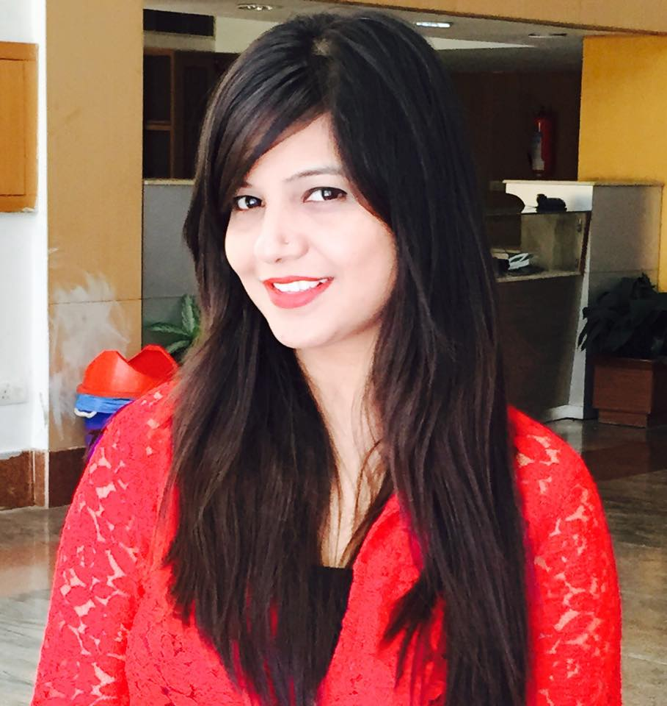

**Name:** Neha Singh Gupta

**Current Designation: Quality Officer, BRMS, NMC, Hospital UAE,**

**Ph no**. – 8851894994, 971564781271

**Email** – [neha.nagvanshi@gmail.com](mailto:neha.nagvanshi@gmail.com)

Date of birth: 20th Oct 1985

Marital status: Married

Husband’s name: Dr. Nikunj Gupta (M.Ch. Surgical Gastroenterology ,NMC Royal Hospital DIP, Dubai )

#### PROFESSIONAL QUALIFICATION

* **Post Graduate in Industrial Relation & Personal Management (IRPM)(Equivalent to MBA)** specialization in Human Recourse Development & Labor Law from Mahatma Gandhi Kashi Vidyapith Varanasi in 2008-09.
* **Diploma in Hospital Administration** from Apollo Hospital.
* One year **Diploma in Computer Software (DCS**)from APTECH.
* One year **Diploma in Computer Application** from AISECT.

#### EDUCATIONAL QUALIFICATION

* Graduation from Mahatma Gandhi Kashi Vidyapith. Varanasi
* Intermediate from UP Board.
* High School from UP Board.

#### EMPLOYMENT RECORD:

* Currently working as Quality officer at BRMS, Dubai Health Care City, UAE.
* Quality Manager at Jindal Institute of Medical Sciences, Hisar, Haryana.
* Administrative Officer in School of Telemedicine & Bio-Medical Informatics, SGPGIMS, Lucknow (2011 - July 2015)
* Event Manager under School of Telemedicine (Organizing CME, Conference)
* Worked teleophthalmology Project under School of Telemedicine & Bio-Medical Informatics, SGPGIMS, Lucknow (2009-2011)

**Profile:** Project Coordinator

* Worked in Samsung Service Center as an Assistant HR.

#### Scientific presentations / Conference Papers

* Tele-Ophthalmology at Community Health Center–SGPGI Case Study, Neha Singh, Indra Pratap Singh, VikasKanaujia, Kumudini Sharma, S. K. Mishra, 8th International Conference of Telemedicine Society of India, Coimbatore, 2012
* Importance of human resources in telemedicine program, Gupta N. S., Daman R., Singh I. P., Mishra S. K.; 10th International Conference of Telemedicine Society of India, Bhopal, Madhya Pradesh, 2014

#### Workshop / CME / Conferences

* Digital Library Workshop on ERMED Consortium at SGPGIMS Telemedicine Programme; 21May 2010
* Regional Workshop for Sensitization and Awareness on National Medical College Network (NMCN) at SGPGI, Lucknow; 13-14 Feb 2014

#### TRAINING

* One-month training attended on **“Labor Welfare”** organized by NTPC Shakti Nagar In 2008.
* Two days’ workshop attended on **“Human Resource Development** “organized **by** Mahatma Gandhi KashiVidyapith, Varanasi on 2008.
* Three Months Summer Training at **“Hindalco”** in HR department.

#### KEY COMPETENCIES

* Skilled in Project Management – Participatory Planning, Monitoring Management.
* Skilled in Management Information System (MIS).
* Good in writing and oral communication in Hindi, English.
* Ability to work under stress and within time frame.
* Skilled in computer applications.

#### Personal interests

* Adventure sports
* Music and dance
* Exploring different geographical locations and cuisines