**ANGELLANGOIRI 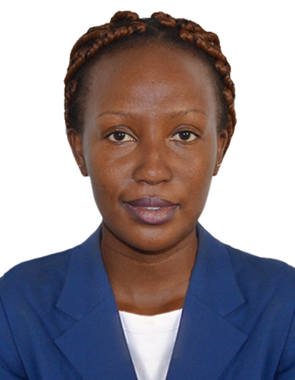NGANGA**

**Contact** : +971582689743

Religion :Christian

Visa Status :visit visa

Emai. :angelnganga90@gmail.com

OBJECTIVE

To secure a career in a reputed organization which appreciates professional approach and hard work, where I can utilize my knowledge, skills and experience in contribution towards fulfilling the company’s growth objectives and develop my career.

* PROFFESSIONAL EXPERIENCE

**MAY 2019- JANUARY 2020**

**Employer:** PLATINUM CREDIT LIMITED

**Department :Administrative _Receptionist**

**Roles and responsibilities**

* Generating leads and doing follow ups on prospective client.
* Fed clients details and monthly updates and reports on excell.
* Applying sales techniques and closing sales to sell the company’s services and also offering after sales support.
* Representing the company in events and marketing the company’s products.
* I have also handled FOSA and reception answering customer queries, checking customer account balances and loan balances as well as providing more information on on company’s products.

**DECEMBER 2017 -JANUARY 2019 SORTMASTERS LIMITED**

**Position: Customer service representative**

* Received clients’ complaints, solved them according to the company’s policy and guidelines and ensured that the clients were satisfied.
* Assisted in sales by recommending to clients the best alternative to the products that the company was offering.
* Received calls and transferred them to the respective departments.
* Compiled reports on overall guest satisfaction on the company’s services and products.
* Updated all the customers’ information in the company’s database

**Andrews Apartments**

**Designation:Room Attendant**

**2014-2016**

**Task Assigned**

* To report for duty punctually wearing the correct uniform and name tag at all times.
* To collect and sign for the floor master key and room report from the housekeeping office and return them at the end of the shift.
* Respond promptly to requests from guests and other departments
* Fill cart with supplies and transport cart to assigned area.
* Replace dirty linens and terry with clean items.
* Enter guest rooms following procedures for gaining access.
* Make beds fold terry and clean bathrooms.
* Remove trash, dirty linen, and room service items.
* Ensure the hotel establishes standards of cleanliness.

**EDUCATION BACKGROUND**

**SEPTEMBER 2014- APRIL 2018 CHUKA UNIVERSITY**

Bachelor’s Degree in ECONOMICS AND STATISTICS

**JANUARY 2010 - NOVEMBER 2013**

High school diploma - ST FRANCIS GIRLS HIGH SCHOOL

**HOBBIES**

Reading Books,

Watching Movies

Trying out new Recipes.

**Refrences.**

**Upon request**