**RESUME**

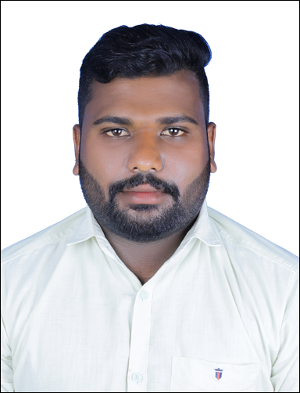

ANANDHU S

MUSAFFAH

ABUDHABI

Mob: 0525449950

as46uae@gmail.com

**PERSONAL STATEMENT**

An extremely motivated individual with a natural ability to solve accounting and financial problems. An innovative thinker with impeccable attention to detail who is also a friendly and approachable individual. Im a qualified accountant looking to join a growing organization that’s committed to hiring a diverse workforce.

**KEY SKILLS**

. Excellent organizational skills with the capacity to deal with multiple tasks at the same time

. Debtor and purchase ledger reconciliation.

. Experience in liaising with banks, auditors, and legal departments.

. Account reconciliations, book keeping, accrual accounting, budgeting processes, and payroll.

. Ability to deal with enormous quantities of financial data.

. Accurate recording of all cash activity on a daily basis.

. Detailed knowledge of electronic banking systems.

. Numeracy skills credit control,, updating spreadsheets, and MS Office and excel.

. A team player with outstanding oral and written communication skills.

**Academic Qualifications**

2016-2017: Master’s degree in commerce – mahatma Gandhi University Kerala

2013-2015- Bachelor degree in commerce - mahatma Gandhi University Kerala

2009-2010 – higher secondary education - Kerala vocational higher secondary education

EMPLOYMENT HISTORY

Head accountant FAHIL AL MADEENA SUPERMARKET 2020-present

Head accountant SAMA AL BUSTAN SUPERMARKET august 2018-2020

**Responsibilities**

Ensuring that the company’s accounting records were accurate and complete through the maintenance of a framework of internal controls

. Explaining the intricacies of the organization’s financial workings to individuals with no knowledge of finance

. Management and supervision of accounts team

. Improving the company’s accounting controls and processes to help the firm run efficiently and effectively.

T

**Certifications**

**Diploma in Professional Accounting**

**G TECH computer education**

**January 2015**

**Personal Profile:**

**Name : ANANDHU S**

**Father’s name : SARNGADHARAN**

**Date of Birth: 24/03/1992**

**Gender : MALE**

**Marital Status : Single**

**Languages Known : Malayalam, English, Hindi &Tamil**

**Passport number : R4910436**

I hereby declare that the above written particulars are true to the best of my knowledge and belief.

Date:

Place: ABUDHABI **ANANDHU S**