CURRICULAM VITAE
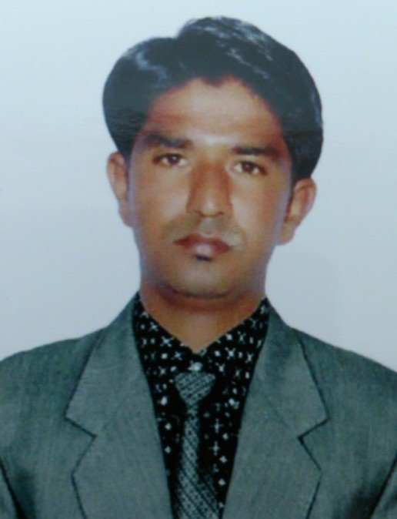
Chinna Sayanna Pothuganti
+971-561458040
+971-554815024
E-mail: chinna_pothuganti1@yahoo.com
------------------------------------------------------------------------------------------------------------
Career Objective:
Highly skilled Individual prefers to work as HVAC Supervisor or Team lead especially in Middle East Asia. I would like to work in a creative and challenging environment where there is scope for upgrading my skills and knowledge. I would like to have an opportunity to contribute effectively in organization. My aim is to contribute my work proficiency to the best of knowledge.
Academic Background:
- SSC – Secondary School Leaving Certificate Board of Hyderabad, Andhra Pradesh, India.
- Diploma in HVAC--Sathya Technical Institute, Andhra Pradesh, India.

Present Working Address: Working as a Team Leader in American Breeze Middle East LLC (Dubai- UAE) from 04th August 2016 to till now.

Organizing daily work schedule and submit work status report to Engineer and Manager.
Commission of Chillers, Multifunction of Dehumidification Systems, Fahu, Ahu, Vrf.
Pre commission Checklist, making Start up Record and trouble shooting of all above mentioned systems.
Delivering unit shipments to the site and issue the parts under warranty (If the parts not repairable).
Will do also office paper work like making invoice,warehouse inventory,cheque collection and deposit etc.

Experience Highlights:
Company : X-fix technical service [Sub contract with B.R.F]
Period : 01st June 2015 03rd August 2016.
Designation : HVAC/R technician cum driver [Team leader]
Job Description : Maintenance FAHU, AHU, FCU and refrigerators all kind relatives HVAC.

Company : JW Marriott Hotel
Designation : HVAC Technician
Job Description : Maintenance Chillers, FCU, AHU, FAHU, and refrigerators, ice machine.
: Preventive maintenance of Exhaust Fan , Fresh Air Fan Motors.
: Handling Gust Room complaint and

Company : Comtel LLC Dubai
Period : 29th Mar 2013 to 19th October 2014.
Designation : Sales Representative

Job Description : Utilized a disciplined sales approach using the proven company sales process.
Builded financial and life cycle analyses to quantify value from the customer’s perspective.
Consistently met the assigned sales objectives.
Possessing Leadership character along with the desire, and skills to manage the entire sales cycle.
Through Technical knowledge in the HVAC industry for the past 10 years.

Company : Readiness Management & Support L.C (RMS), Camp Taji, IRAQ.
Period : 04th Nov 2004 to 30 Nov 2011.
Designation : HVAC Team Lead
Job Description : Install, maintain, trouble shoot, and repair air conditioning and heating systems, refrigeration systems, and electrical systems.
Performed daily operations on boilers including blowing down and pump maintenance.
Performed preventative maintenance tasking on HVAC equipment.
Maintained and repaired buildings' HVAC systems, replacing worn and defective parts.
Maintained Facilities mechanical, air conditioning, heating and ventilating equipment.
Resolved technical problems using testing, measuring and diagnostics instruments.
Repaired various parts of air condition and heating systems by replacing malfunctioned parts.
Tested equipment by using pneumatic and/or electronic tools.
Listed the needed supplies of spare parts, equipment and tools necessary for repair and maintenance.
Repaired and maintained equipment through brazing, soldering, and pipe fitting.
Expertise in steam distribution equipment and energy management systems.
Strong ability to express through verbal and oral communications
Outstanding knowledge of HVAC systems
Maintain environmental conditions by installing and maintaining both heating and cooling systems
Assembling all type HVAC equipment ( FAHU, AHU etc )
Assisted HVAC technician in installing and managing cooling and heating systems
Provided preventive maintenance solutions
Assisted in engineering design services for ducts and other systems as appropriate
Monitored duct pressures and external air pressures on a regular basis
Managed paperwork associated with HVAC procedures
Maintained, installed, inspected, repaired and adjusted air conditioning, heating and refrigeration equipment including pumps, evaporators, chillers, boilers and other related equipment in District buildings, plants and facilities; troubleshot operating problems and provided Installed air distributes system .
Install water intake and drainage lines and pipes; recharge air conditioning/heating systems with refrigerants as necessary; install, maintain, insulate, and repair pipes for chilled water and other systems; install electrical lines from panel to unit to include wiring of components, thermostats, circuit breakers, power distribution switches, and safety devices.
Operated and performed minor maintenance on a variety of equipment and tools including drills, saws, welders, testers, air lifts, vacuum pumps and air balance equipment in a safe and efficient manner recommendations for solutions; performed preventative maintenance as needed.
Directed work of semi skilled assistants on a specific job.
Determined safety precautions and observed safe and effective work methods; completed daily duties in a timely and effective manner.

Company : Standard Air Conditioning Company , Mumbai, India.
Period : 02nd January 2002 to 20 October 2004
Designation : A/C Technician
Job Description : A detailed understanding of all document management processes. Conversant with engineering documents of different disciplines like Mechanical / Electrical Inst.Civil & Structural and Equipment. Able to identify the category of Doc & Dwg.for each discipline e.g. Process: Basis of Design, P&IDs. Mach: ISO, Stress Analysis reports etc. Elect. & Inst.: Cables layout dwgs. Loop & logic diagrams etc. Civil & Structural: Foundation dwgs. Structural dwgs etc. Equipment: Data sheets & Specifications, Fabrication dwgs etc. And carry out proper filing of the Latest Revision of the documents for each discipline, category wise and also maintain proper Index of Documentation for easy identification.

HONORS & AWARDS

- Employee of the month award from the HVAC Department Supervisor, RMS- Iraq
- Honored and Certificate of Appreciation from US Army-Iraq

Software Expertise:

Operating System : Windows, Basics, MS Office 2007

Personal Profile:

Name : Chinna Pothuganti
Date of Birth : 10th July 1983
Mother Tongue : Telugu
Marital Status : Married
Languages Known : English, Hindi and Telugu

Passport Details:

Passport No : R8138761
Date of Issue : 14 August 2017
Date of Expiry : 13 August 2027
Place of Issue : Dubai - U.A.E.
Driving License : 2036323 – Dubai
Valid until : 14th May 2024

I do here by declared that the above mentioned particulars are true and correct to the best of my knowledge

Place: Dubai Yours Obediently,

Date: Chinna Sayanna Pothuganti

