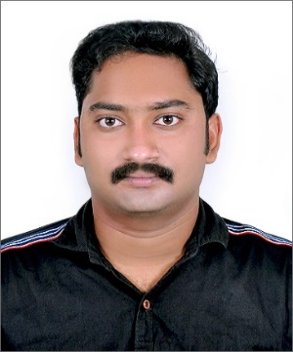

**Kevin Christapher**

**+971-554103351, Ajman UAE**

[**kevinchristopher135@gmail.com**](mailto:kevinchristopher135@gmail.com)

**OBJECTIVE**

I am looking forward to work in a challenging corporate environment where I can enhance my skills, at the same time giving priorities to the organizational objectives.

**COMPUTER SKILLS**

* MS Office Application (MS Word, MS Excel, MS Power point, OutLook).
* Tally.

**PROFESSIONAL EXPERIENCE**

**Saji Oommen & Co**

Working as Accounts and Audit assistant From (***December 2017*** to **Present)**.

**Roles & Responsibilities:**

* Enter accounting bills of many firms (sales, purchase bills etc.).
* GST filing, Income tax filing, TDS filing.
* Preparation and finalization of final accounts, Audit report (Winman CA).
* Managing colleagues, workloads and deadlines.
* Dealing with insolvency cases.
* Documents financial transactions by entering account information
* Provides financial information to management by researching and analyzing accounting.

**EDUCATIONAL CREDENTIALS**

|  |  |  |
| --- | --- | --- |
| **Exams** | **Institution** | **Year of Passing** |
| B.Com | University of Kerala | May 2016 |
| Plus 2 | Kristraj higher secondary school, Kollam | March 2013 |
| I.C.S.E | Infant Jesus Anglo Indian Boys High School | March 2011 |

**INTERESTS & OTHER ACTIVITIES**

* Net Browsing, Music, Photography and Adventure trips.

**PERSONAL DETAILS**

|  |  |
| --- | --- |
| Date of Birth | February 17, 1996 |
| Sex | Male |
| Marital Status | Single |
| Father Name | Christapher |
| Nationality | Indian |
| Passport Number | **R1117081** |
| Language’s Known | Speaking: English, Malayalam.  Read and Write: English, Malayalam |

Hereby I acknowledge that the above provided information is true to the best of my knowledge

Kevin

_______