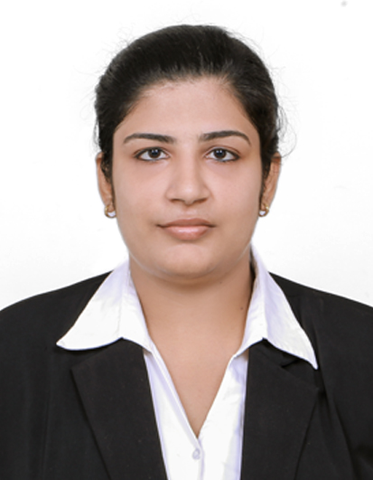

VICTORIA TONY
victoriavt1990@gmail.com
Mob:0091-8606592126

CONTACT DETAILS  ThozhuthumparambilHouse  Karukutty P O  Ernakulam -  Kerala, India  PERSONAL DETAILS  Fathers Name :T. P Varghese  Date of Birth : 23/09/1991  Age : 29  Gender : Female  Marital Status : Married  Nationality : Indian  Religion : Christian R C  Blood Group : A-ve  Languages Known  - English  - Tamil  - Malayalam  - Hindi  PASS PORT NO : R9755855  DATE OF ISSUE: 07/03/2018  DATE OF EXPIRY:  06-03-2028 | Career Objective:  To seek placement with a reputed, progressive organization in order to utilize my skill & ability to the optimum level and further development of my career and organization goals. To adapt and learn new technical possibilities and skill worth in new developments. .  EDUCATIONAL QUALIFICATIONS :  KEY SKILLS :  - Presentation skill  - Hard working with positive attitude  - Leadership skill  - Building customer relationship  - Team Coordination & Helping Mentality  - Quick learner and observer  - Ability to adapt as a team member & team leader when needed.
  Course | Year | Board
  MBA ( Finance with Human Resource ) | 2014 | Mahatma Gandhi University
  BBA | 2011 | Mahatma Gandhi University
  Higher Secondary Examination, Commerce | 2008 | Higher secondary board
  Secondary School Leaving Certificate Examination | 2007 | State board

WORK EXPERIENCE:

1.Experience as an Event cordinator in Dezire Events and Entertainments, Cochin.2-06-2011 to
30- 05-2012
2.Experience as a Customer Relationship Manager in Guardian Multi-speciality Hospital. kaipamangalam,Thrissur.6-10-2015 to 16-10-2016
3.Experience as an Accounts & Event Manager in Dezire Events & Entertainments, Cochin.
21-01-2017 to 23-09- 2019

PROJECT EXPERIENCE

- An organization study report on KPL OIL MILLS (INDIA) Pvt.Ltd.Irinjalakuda,Thrissur
- A study on assets & liability management at KERALA SOLVENT EXTRACTION (INDIA) Pvt.Ltd. Irinjalakuda , Thrissur
- A study on Thrift & Credit operations. Muncipality, Irinjalakuda

OTHER INFORMATION:

- Product presentation, 2012-13
- Project on waste management, 2013-14
- New business plan 2013-14
- Explore the biz world 2013-14
- 24 Hours project presentation (Second Price)2010-11
- Advertising Campaign (Third price )2010-11

COMPUTER KNOWLEDGE:

- Diploma in Corporate Finance & Control - SAP From G-Tec
- Windows XP ,Windows 7
- Tally ERP 9
- Ms office ,Excel , Word & Power Point

DECLARATION

I hereby declare that all the information furnished above is factual and correct to the best of my knowledge and belief. Hope you will consider my past experience and given me an opportunity to serve in your esteemed organization

Place: KARUKUTTY

VICTORIA VARGHESE

