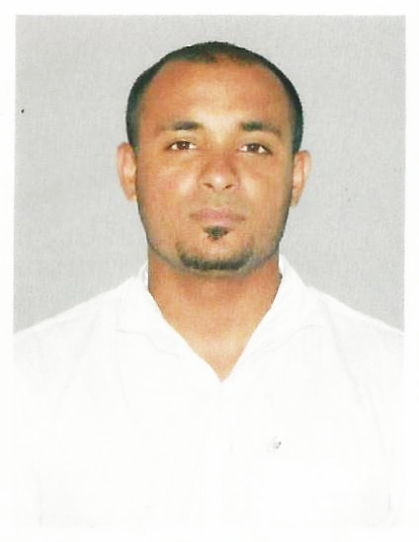

SHARATH RAVINDRAN.K
Mob: +91 9567946187
Email:sharathravindrank.karyankandi@gmail.com

Objective
To work in a company that promises challenging career in a professional environment that is both supportive and motivating. I will be free to take risks, to innovate, to take pride of ownership in my work.
Personality Traits
- Very energetic, result oriented and organized.
- Have a knowledge store system like LIFO,FIFO.
- Managed and supervise store perfectly.
- Efficient and well behaved person.
- Extremely hardworking self-motivated and able to work independently in a team environment under supervision.
- Keep excellent interpersonal relations with colleagues and ready to help
- Always focused on result oriented

Educational Qualification
- Plus Two –VHSE, Kerala
- SSLC - Board of Public Examinations, Kerala

Technical Qualification
- Diploma in Hotel Management

Computer Proficiency
- MS Office: Word, Excel, PowerPoint
Areas of Interest
- Administration
- Store keeper
Experience
- Worked as a Store Keeper in Ali Alghanim, Kuwait for 3 years.
- Forklift Operating (Without License)

Responsibilities
- Store Entry.
- Store Inward Outward Gate Passes.
- Store Coding System.
- Store LIFO system.
- Store FIFO system.
- Store Inspection skills.
- Store Handling skills.
- Store item or product supervising.
- Store item wise coding.
- Store consumption record department wise.
- Store product aging record.
- Proficient and expert in MS OFFICE(word, excel and power point).
- I always keep knowledge in the fielded of IT and INTERNET WORLD.

Personal Information

- Father’s Name : Raveendran.A.P
- Address : Ravi Nivas, Kuruva, P.O.Kadalayi,
Kannur
- Date of Birth : 27-08-1990
- Nationality : Indian
- Religion : Hindu
- Sex : Male
- Marital Status : Single
- Languages Known : English, Hindi, Tamil & Malayalam
Passoprt Details
Passport Number : J2666777
Place of Issue : Kozhikkode
Date of Issue : 13/08/2010
Date of Expiry : 12/08/2020

Declaration

I hereby declare that the details furnished above are true to the best of my knowledge and belief.

Place: Kannur, Kerala
Date:

SharathRavindran.K

